## **Release Form (Cover Page)**

|  |  |
| --- | --- |
| CSCI Class: | **Data Warehouse Design** |
| Professor: | **Dr J** |
| Term / Year: | *Spring* **2019** |
| Team Name: | **Yellow Team** |
| Student Name (s) | **1.Zachary Reese**  **2. Jonathan Guzman**  **3.Christopher Iverson**  **4.Keenan Lewis-Jolly**  **5. Shawein Smith** |
| Assignment: | **Project Assignment** |
| Date of Submission: | **4/27/2019** |

Satisfaction with learning experience with this assignment (check one):

¨ A. Very useful

¨ B. Useful

¨ C. Little or no use

**Post Mortem** –this section is required (type your important comments/lessons learned here):

*Three or more sentences/paragraphs!*

***Release Note:***

We the undersigned (name in italic will serve as signature), take full responsibility for the work performed related to this assignment and for the work records attached, and also identify both as our own original work contribution:

Signature 1: _______________________________________________

Signature 2: _______________________________________________

Signature 3: _______________________________________________

Signature 4: _______________________________________________

Signature 5: _______________________________________________

Signature 6: _______________________________________________

Table of Contents

**Release Form (Cover Page)** **0**

**Executive Summary 4**

**Project Description 4**

**Project Organization 5**

**Project Plan 6**

**Tasks 6**

**Project Architecture 8**

**OLTP Operational Data Model 9**

**Complete Data Warehouse Design 12**

**Sales**

**Sales WIP 14**

**Sales BEAMS 14**

**Sales DFM 15**

**Sales Data Vault 16**

**Sales Data Mart 17**

**Sales ETL Process 18**

**Queries - Zac & Jonathan 25**

**Production**

**Production WIP 30**

**Production BEAMS 31**

**Production DFM 32**

**Production Data Vault 33**

**Production Data Mart 34**

**Production ETL Model 35**

**Queries - Keenan 38**

**Human Resources**

**Human Resources WIP 43**

**Human Resources BEAMS 43**

**Human Resources DFM 44**

**Human Resources Data Mart 45**

**Human Resources ETL Process 46**

**Queries - Chris 50**

**Purchasing**

**Purchasing WIP 52**

**Purchasing BEAMS 52**

**Purchasing DFM 53**

**Purchasing Data Vault 54**

**Purchasing Data Mart 55**

**Purchasing ETL Process 56**

**Closing Remarks 58**

**DW Generate Script 58**

**Executive Summary**

Adventure Works Cycles is a bicycle manufacturing company that operates around the globe with many locations, over 300 employees, and millions of dollars in revenue. The company’s resellers are located on three different continents: North America, Europe, and Asia. Adventure Works sells a multitude of products including: Bikes, Accessories, Clothing, Components, Services, and more.

**Project Description**

The scope of this project is to create a fully functioning Data Warehouse from the AdventureWorks2014 database. The project is built to Enterprise Data Warehouse standards and consists of the following data marts:

1. Sales: Focuses only on orders sold by a salesperson and tries to answer the following questions, “Which salesperson sold which orders?”, “Which territory was the order sold in?”, and “Where is a product located at an inventory location?”.
2. Production: Focuses on the back end of getting products out the door and answers the following questions, “How much for which product listed?”, “What are the current quantities of an inventoried product?”, and “Where is a product located at an inventory location?”.
3. Human Resources: Focuses on maintaining and updating critical financial and employee records and answers the following, “How much does x employee earn?”, “Are all employees paid on time?”, and “Which person is best suited for this job?”.
4. Purchasing: Focuses on vendors and resellers for AdventureWorks. Answers the questions, “Which vendor makes the most profit?”, “Which vendor purchases the most inventory?”, and “What is the best way to get our inventory to said vendor?”.

**Project Organization**

*Division of Labor*

1. Zachary Reese
   1. Serves as team leader
   2. Guide and advise throughout project
   3. Data Warehouse Modeler
   4. Data Warehouse implementation
   5. SSIS instructor
   6. Sales Data Mart Modeling
   7. Sales ETL modeling
2. Jonathan Guzman
   1. DW Architecture development
   2. Sales data mart implementation
   3. Sales data mart modeling
   4. Sales fact table modeling
   5. Sales fact table implementation
   6. DW modeling
3. Keenan Lewis-Jolly
   1. Production fact table implementation
   2. Production data vault modeling
   3. Production data mart modeling
   4. Production ETL modeling
   5. DW Infrastructure
4. Christopher Iverson
   1. Human resource fact table modeling
   2. Human resource data vault modeling
   3. Human resource data mart modeling
   4. DW initial implementation
   5. Human Resources ETL modeling
5. Shawein Smith
   1. Purchase fact table modeling
   2. Purchase data vault modeling
   3. Software management
   4. Purchase ETL modeling
   5. Project QA

**Project Plan**

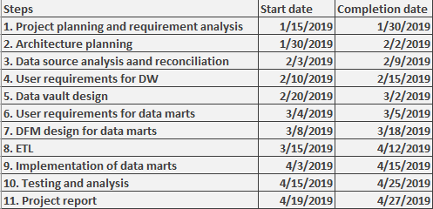

**Tasks**

The following tasks have been identified

1. Requirement Analysis
   1. Form scope of project
   2. Form requirements for the data warehouse and data marts
   3. Form guidelines and standards for the warehouse
   4. Develop division of labor
   5. Select source system, data, and data profiling
   6. Test source system data for quality
2. Architecture planning
   1. Diagram and map overall architecture
   2. Develop and perceive beginning sizing constraints
   3. Initial ETL development
3. Extract and Load Data from Source System
   1. Extract source data
   2. Develop SQL Server configurations for team
   3. Load extracted source data into SQL Server
4. Design and Build Data Warehouse Structures
   1. Development of EDW database built on data vaults
   2. Development of scripts to generate summary tables
   3. Construct data marts using DFM
5. Implementation
   1. Final implementation of DW
   2. ETL models
   3. Develop staging database
6. Testing/QA
   1. Perform data quality tests
   2. Perform integration tests
   3. Perform system and environmental tests
   4. Perform volume and load tests

**Project Architecture**

The proposed architecture diagram is below. The source of the data is AdventureWorks2014 database. Data will be extracted from this database, and transformed using ETL tools such as SSIS with Visual Studio. Then the data will be loaded into the respected data marts for analytics.

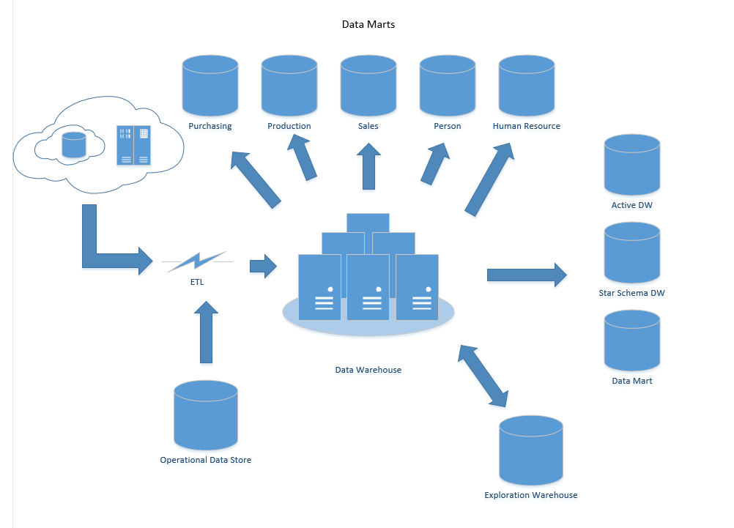

**OLTP Operational Data Model**

Below is the Entity Relationship model of our current operational database. This will be used to populate our data marts.

**Sales**

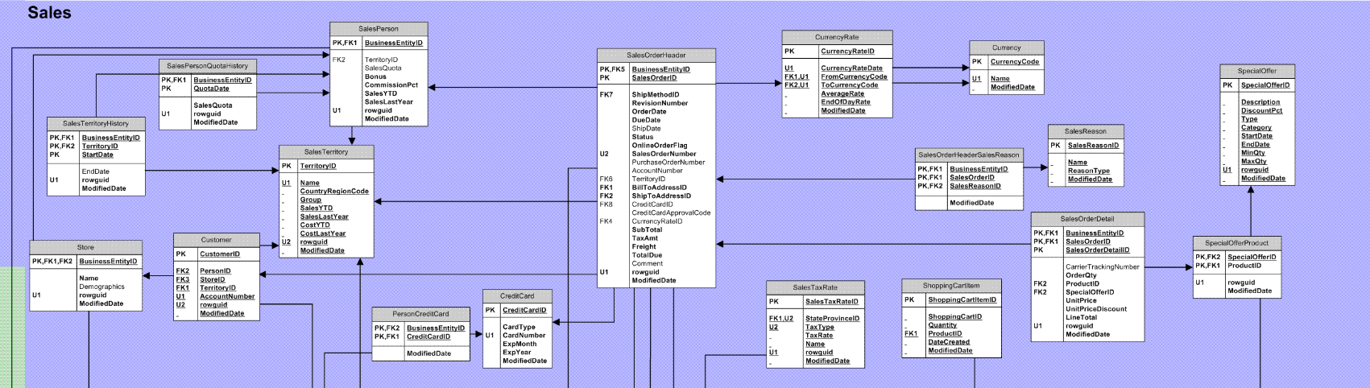

**Purchasing**

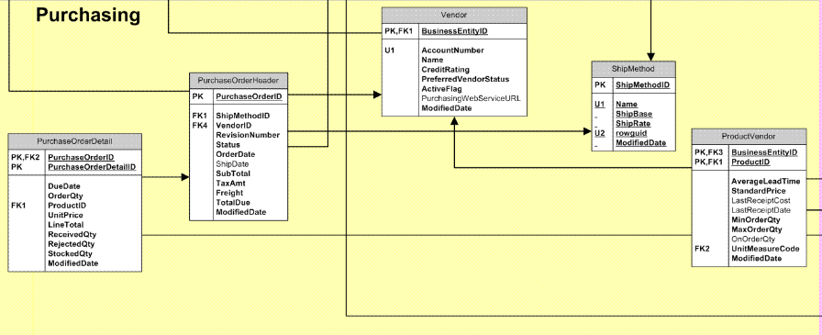

**Production**

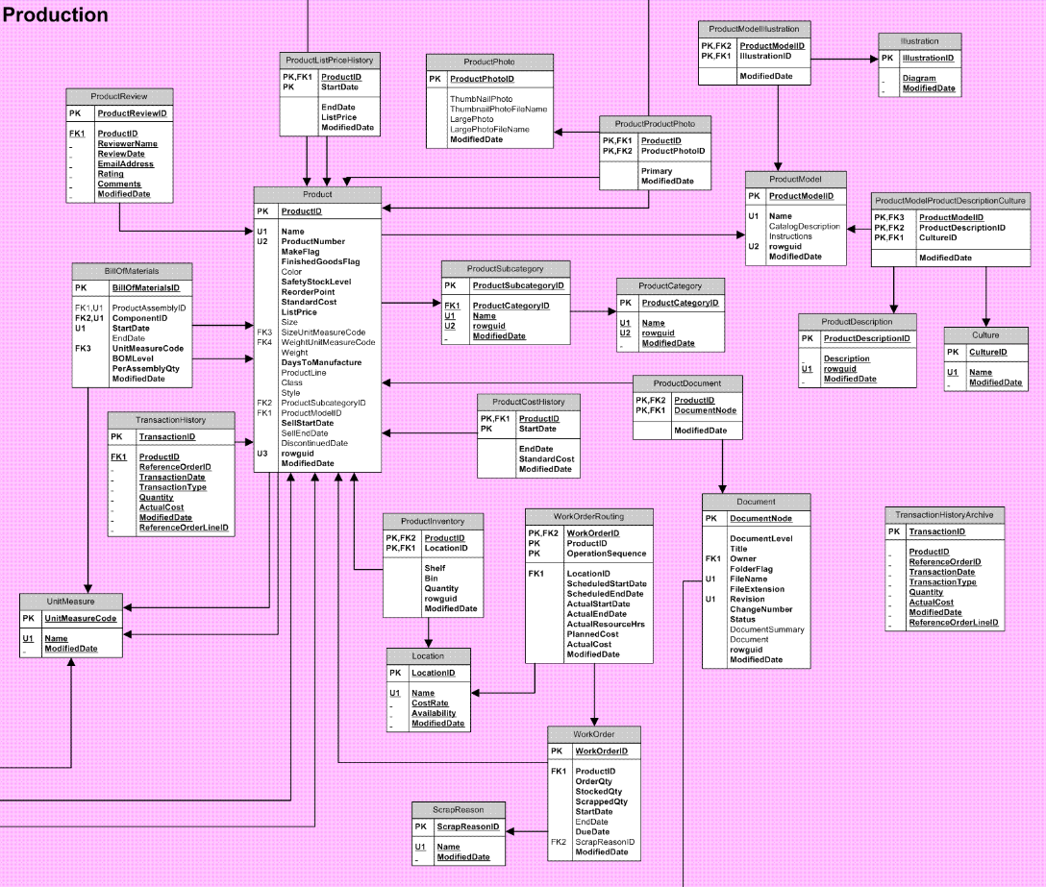

**Human Resources**

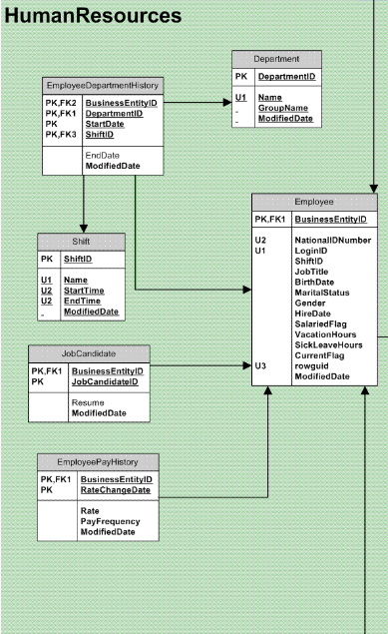

**Complete Data Warehouse Design**

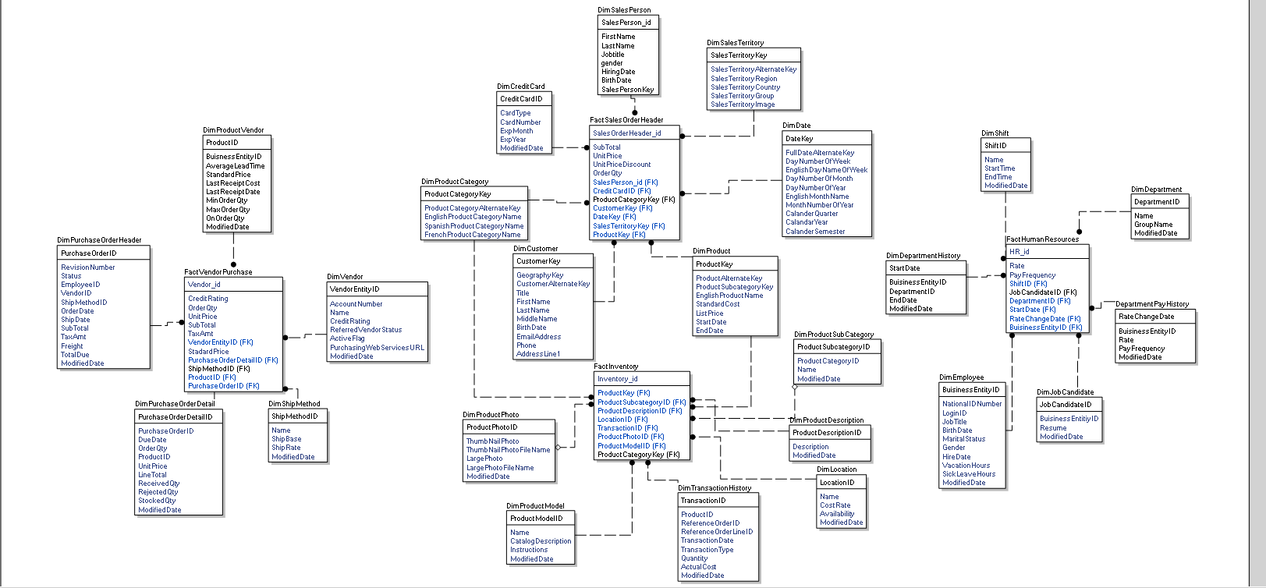

*SSIS*

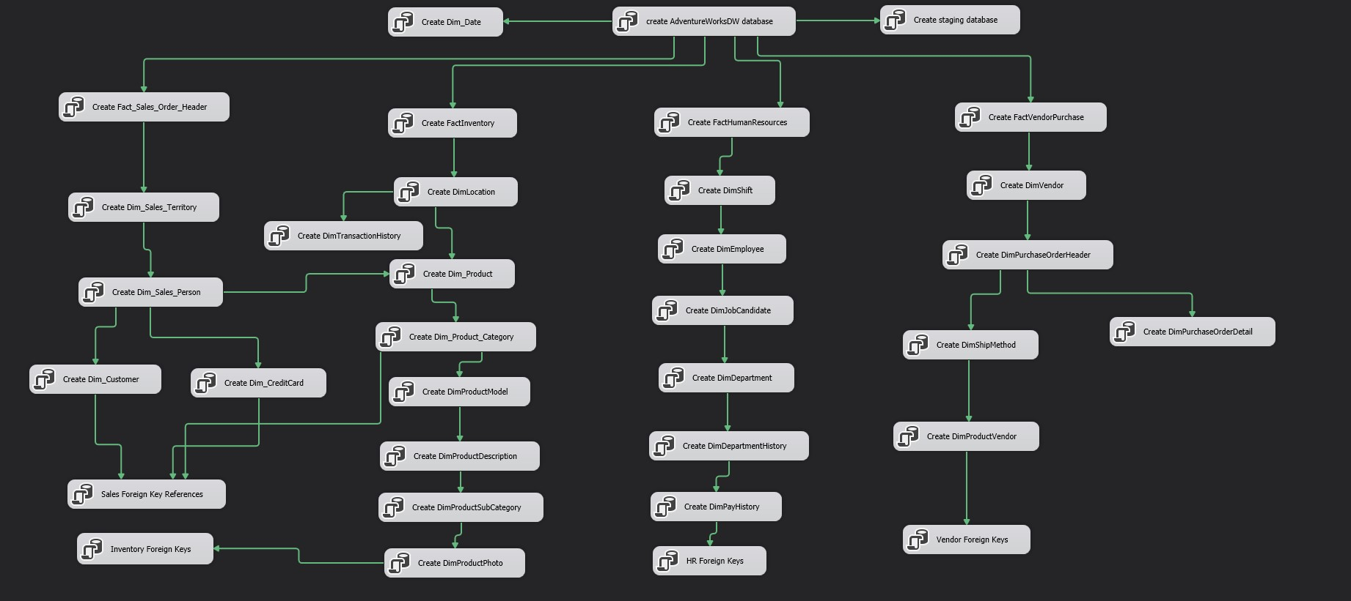

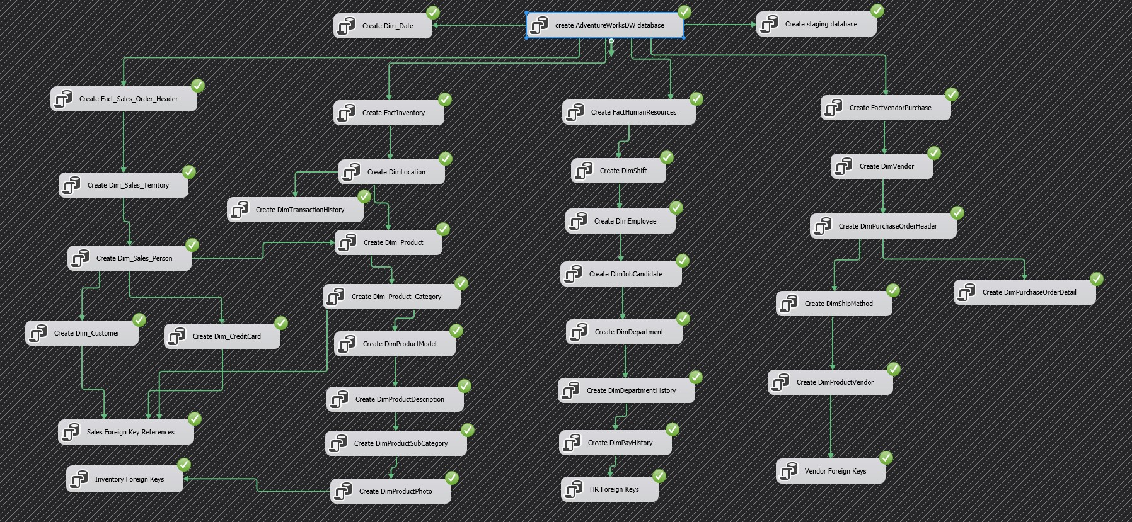

**Sales - Zac & Jonathan**

**WIP Model**

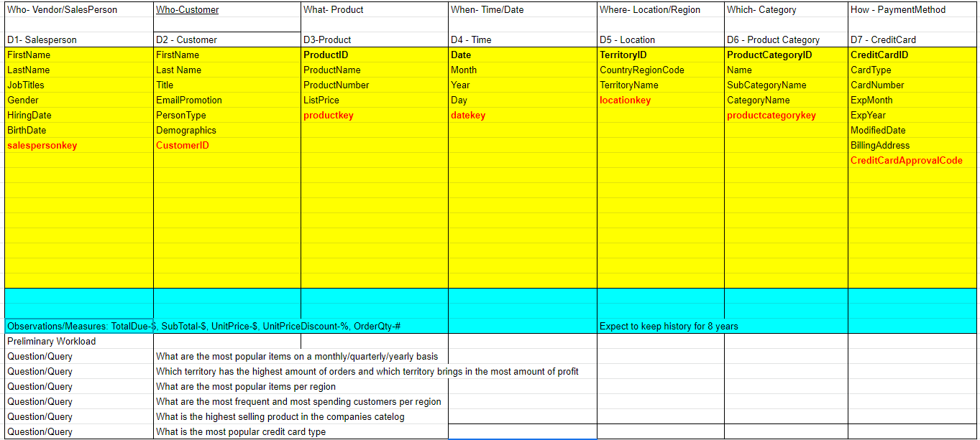

**BEAMS**

*SalesOrderHeader Dimension*

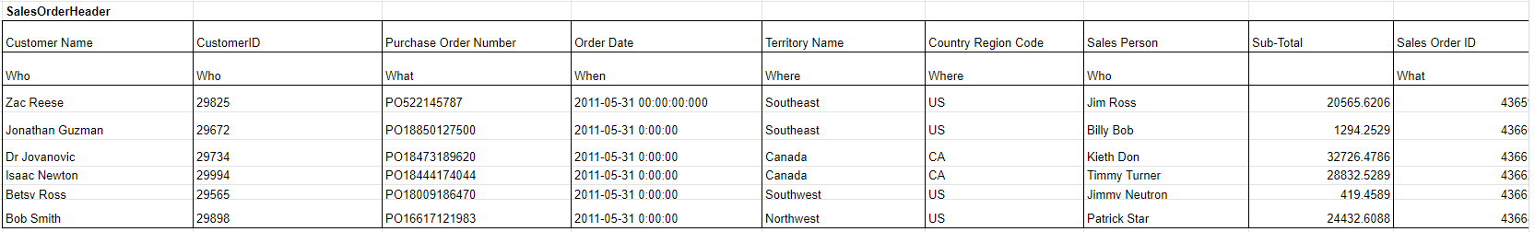

*SalesTerritory Dimension*

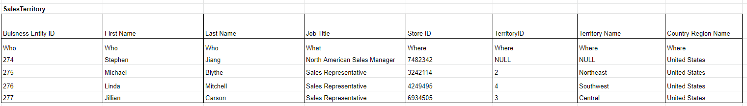

**Data Warehouse Design**

Conceptual Models

Sales - Zac & Jonathan

*Dimensional Fact Model*

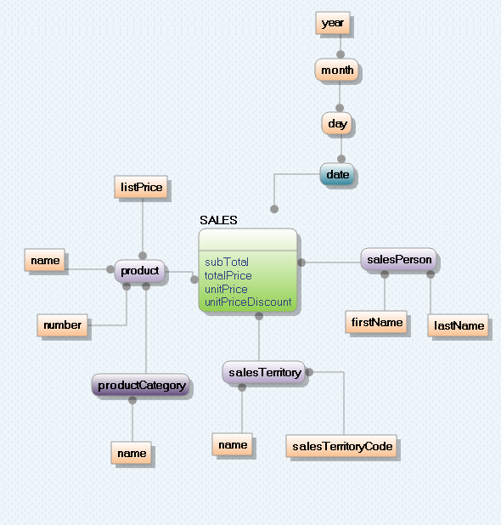

*Data Vault - Sales*

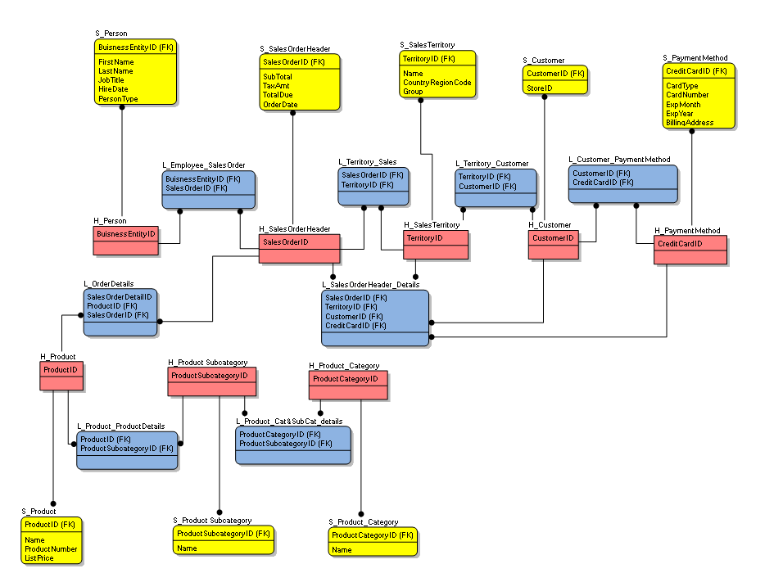

**Logical Model**

Sales Data Mart

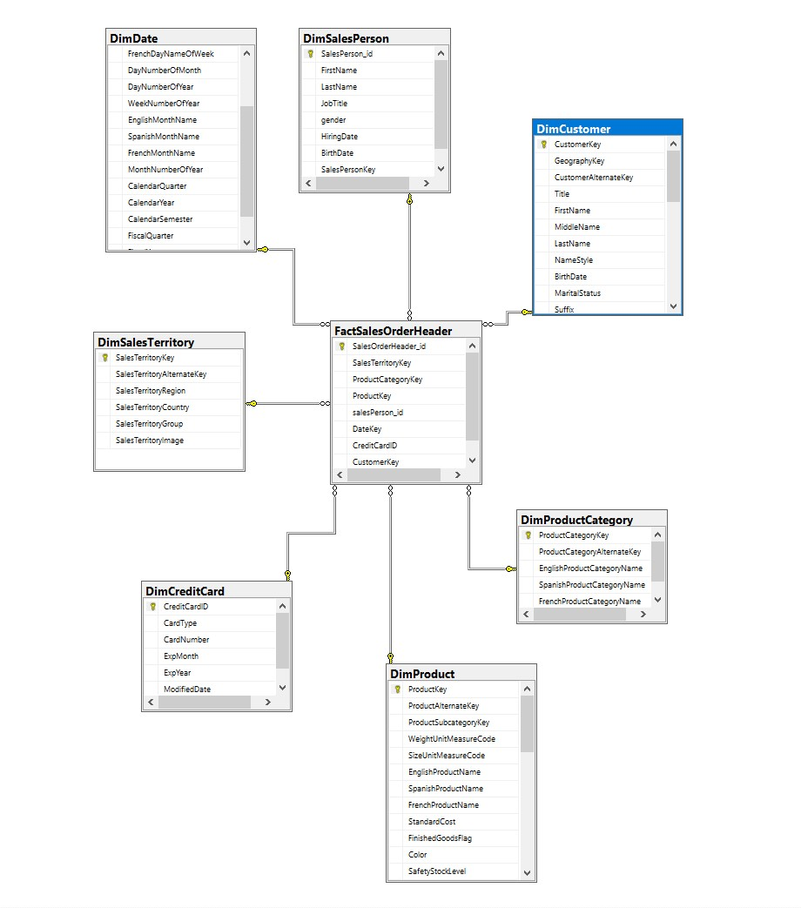

**ETL Process - Sales**

Zac: As group lead, I felt that SSIS was one of the most important areas of focus in the entire DW spectrum. As a group, we have created models to showcase the strength of SSIS in Visual Studio to aid in the ETL process.

1. Show the process of using SSIS to extract data from a foreign source, in this case the data comes from AdventureWorks database, then we transform the data as it is going from non-unicode to unicode, and finally load the data into a separate source, in this case our staging DW.

*Control Flow*

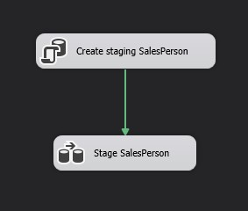

*Data Flow*

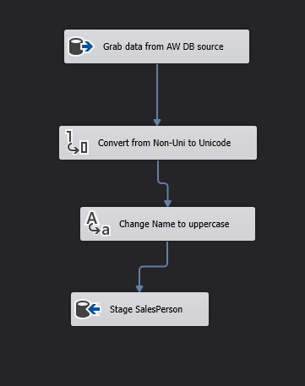

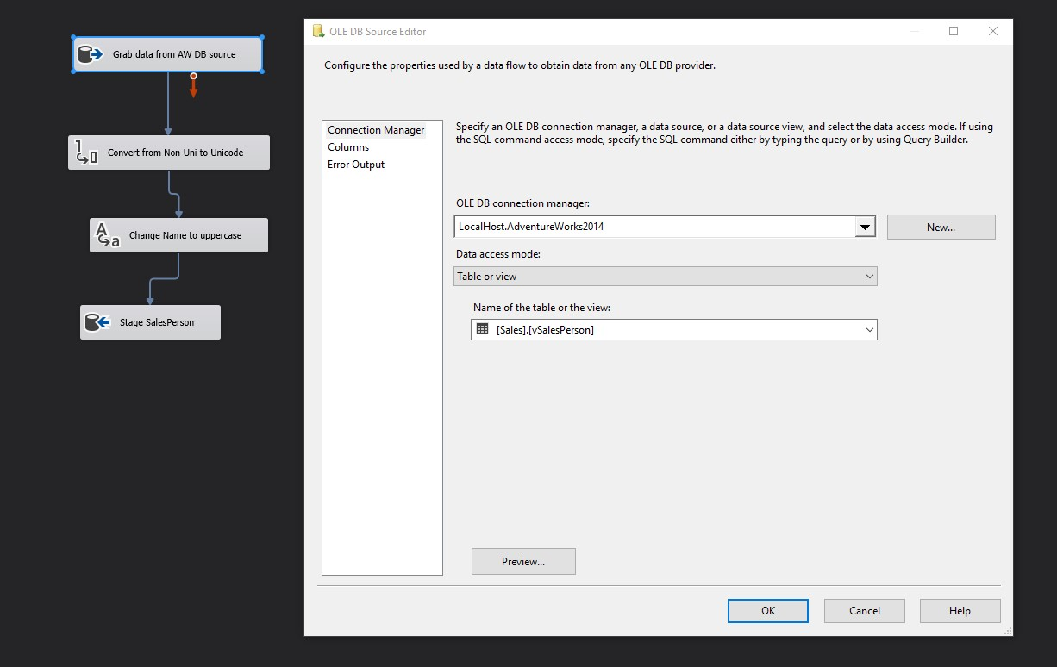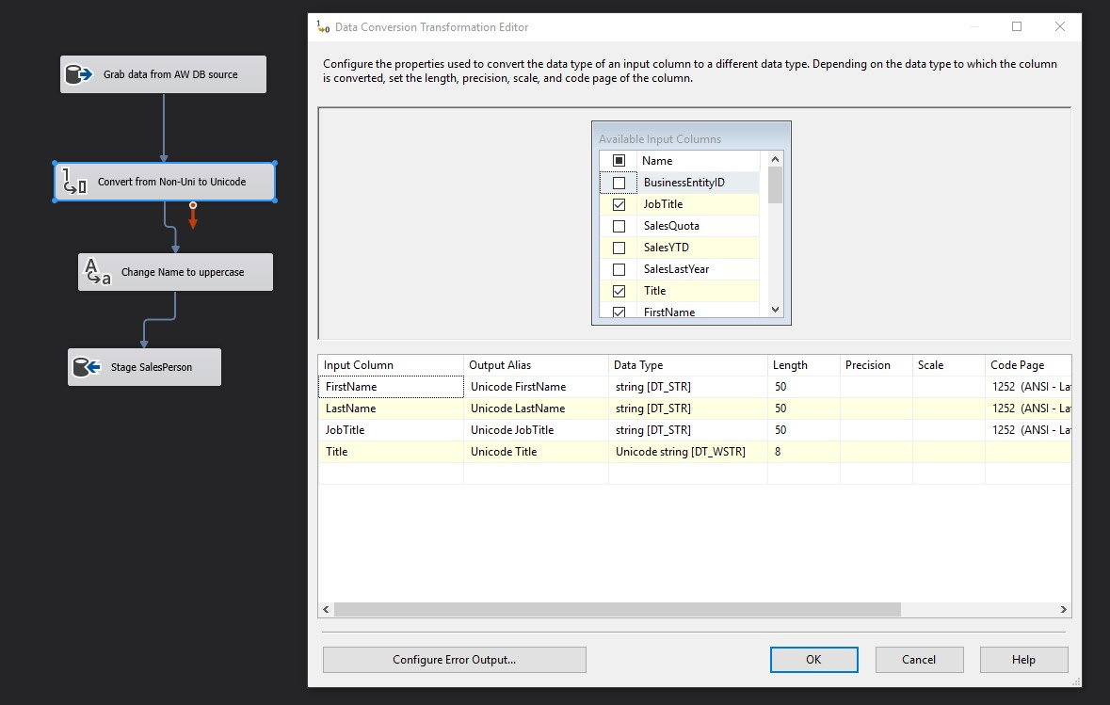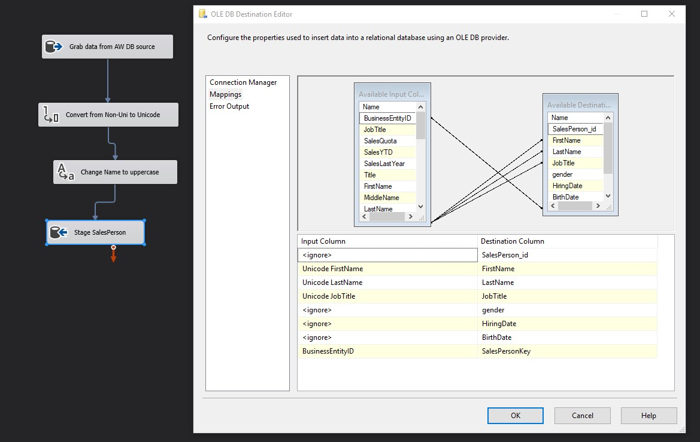

*Final Result*

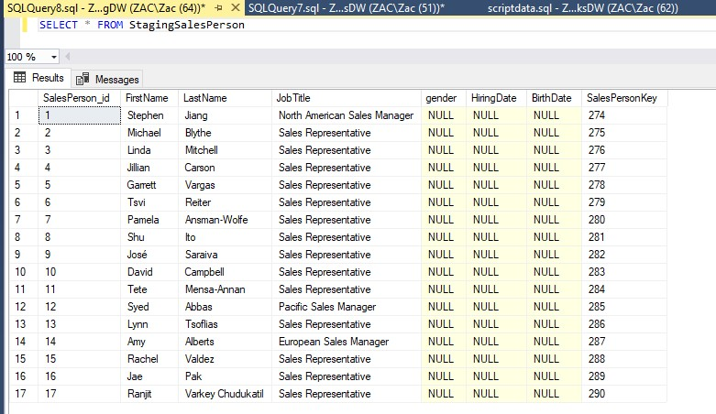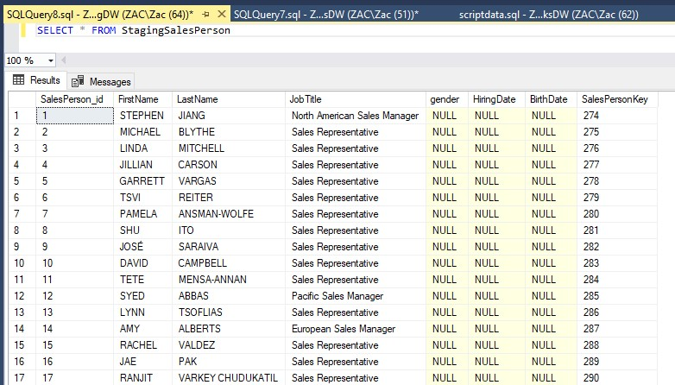

**ETL Process - Sales**

2. Showing the strength of SSIS control flow. In this diagram we are able to extract our data, load it into our staging data warehouse, and verify the contents of the data. We can create an inclusion profile about the data, what it’s contents are, the validity of the data, its usefulness, etc. From there we can choose to load the transformed data to the production data warehouse or further analyse the data, followed by emailing the report.

*Control Flow*

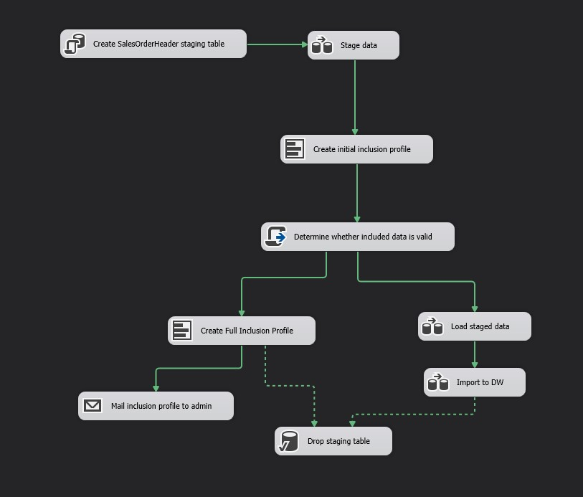

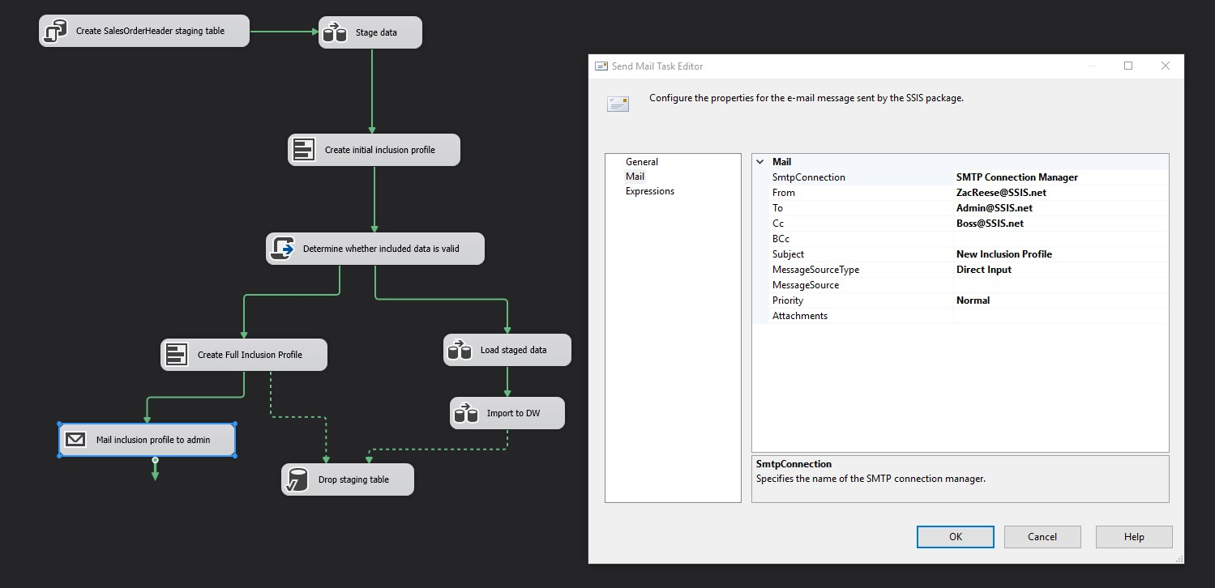

**ETL Process - Sales**

3. Here we highlight the conditional split function in SSIS, we can separate data based on certain constraints for further analysis.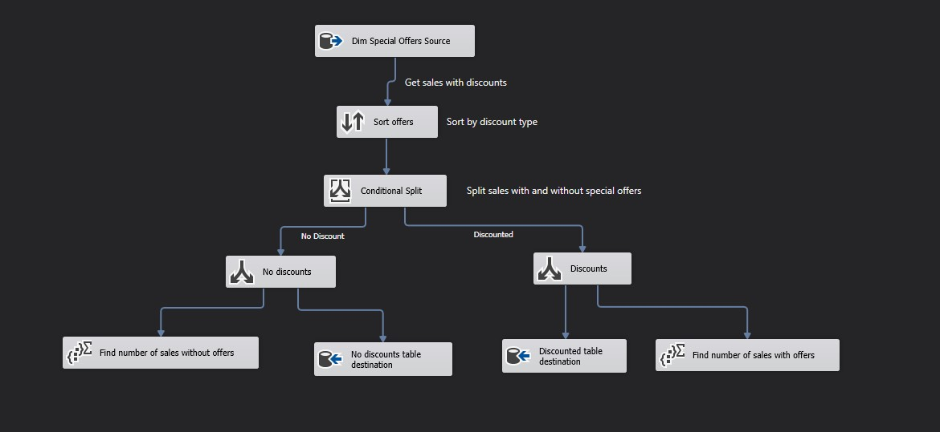

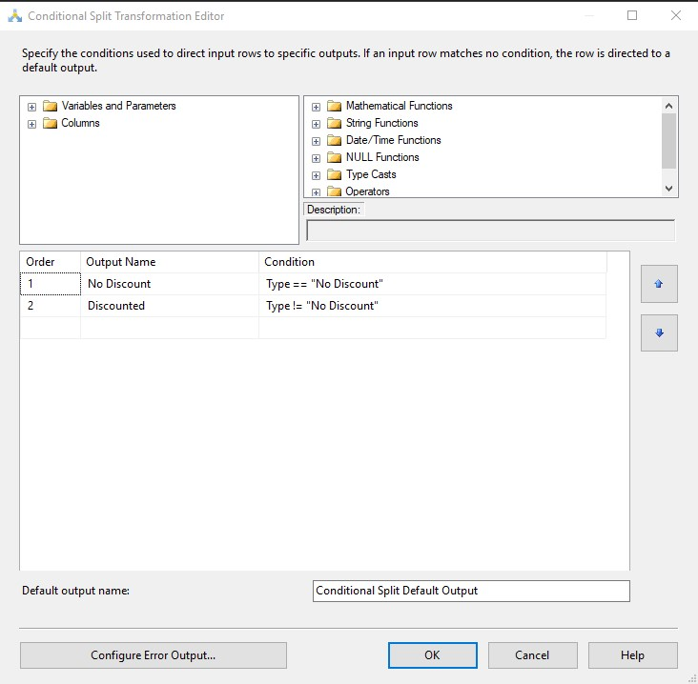

**SQL Queries - Zac**

1. Which country buys the most products over the internet? And how much have they spent in total?

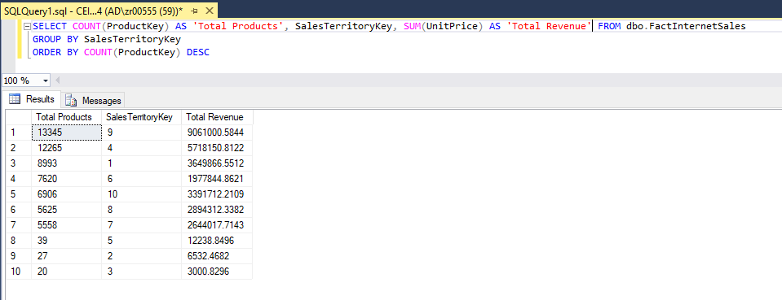

2. What is the most popular credit card type?

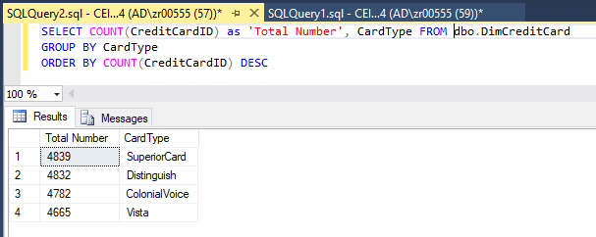

3. Who is the top 10% of sales persons by total sales revenue?

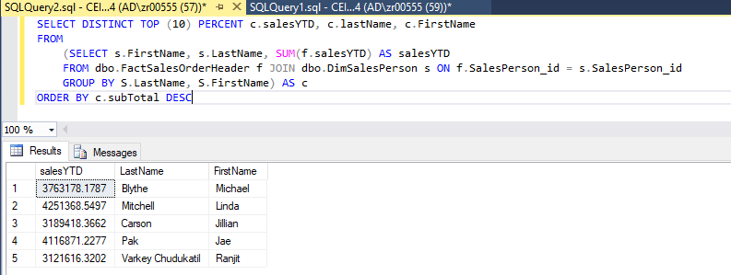

4. Which vendors have the most profit when accounting for number of employees (Profit/NumOfEmployees)

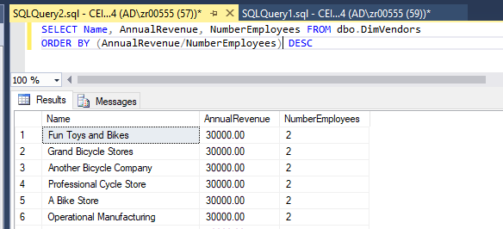

5. Select top 10 best exchange rate currency

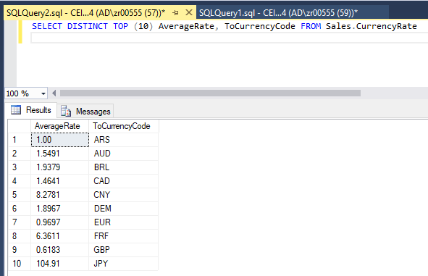

**SQL Queries - Jonathan**

1. The popularity of each product category per territory and how many of each product category was order per territory.

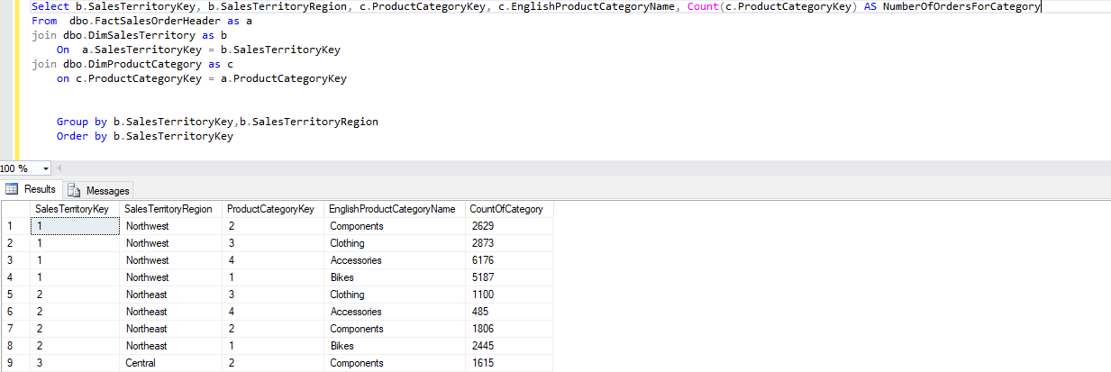

*Comparison to the code need to show the same data between a data warehouse and a regular database

*database code

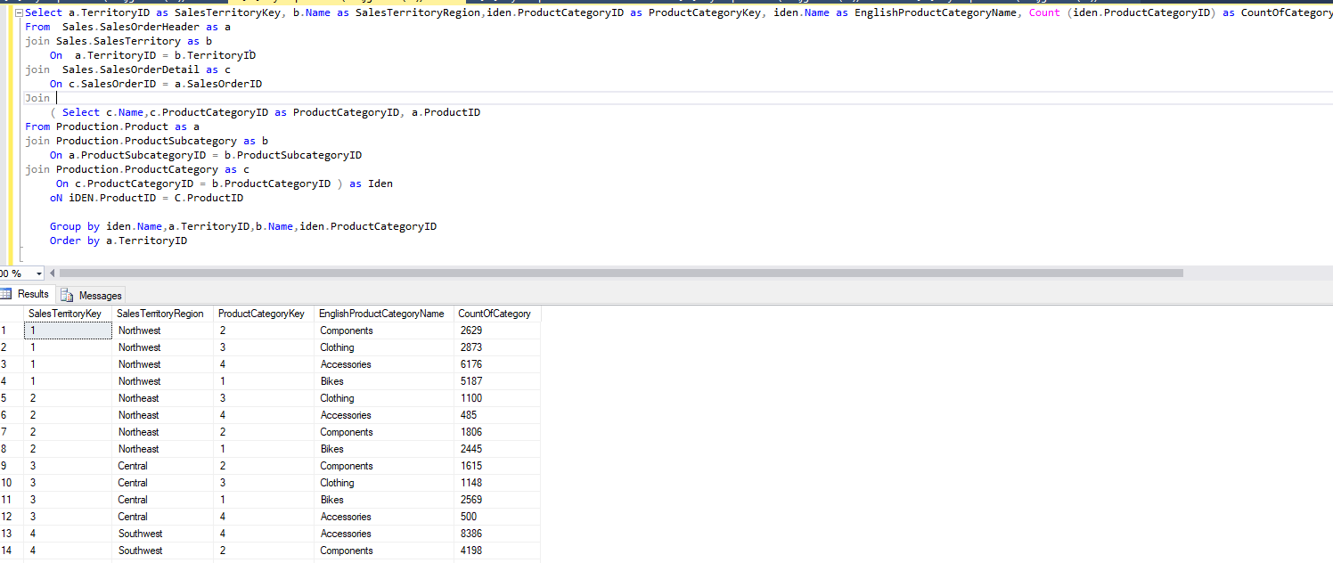

2. Total number of orders per region

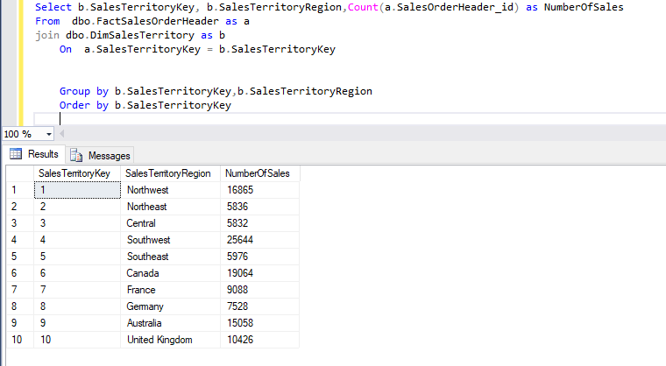

3. Total income per territory till the current point in time

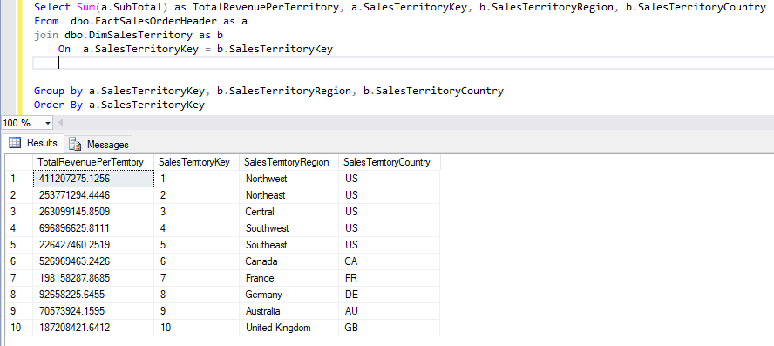

**Production - Keenan**

**WIP**

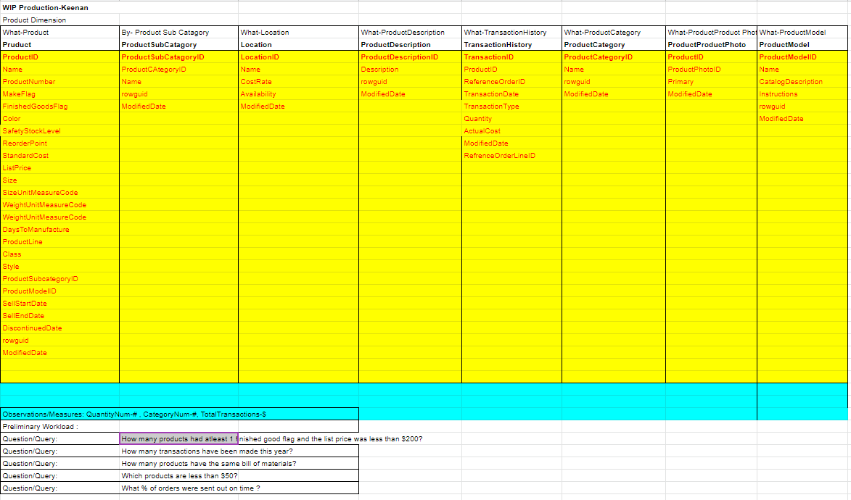

**BEAMS**

*UnitMeasure Dimension*

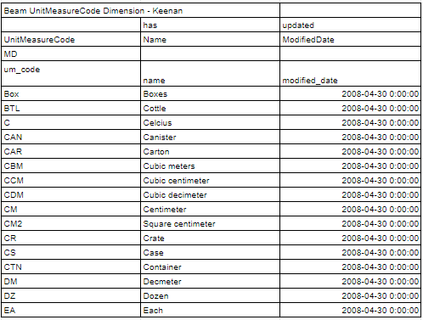

**Data Warehouse Design**

Conceptual Models

Production - Keenan

*Dimensional Fact Model*

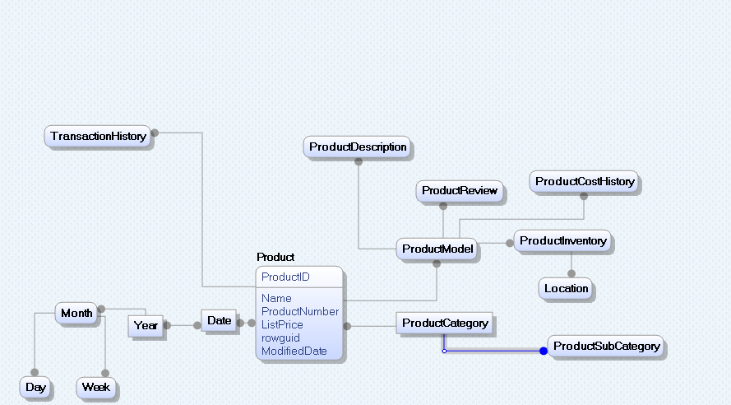

*Data Vault*

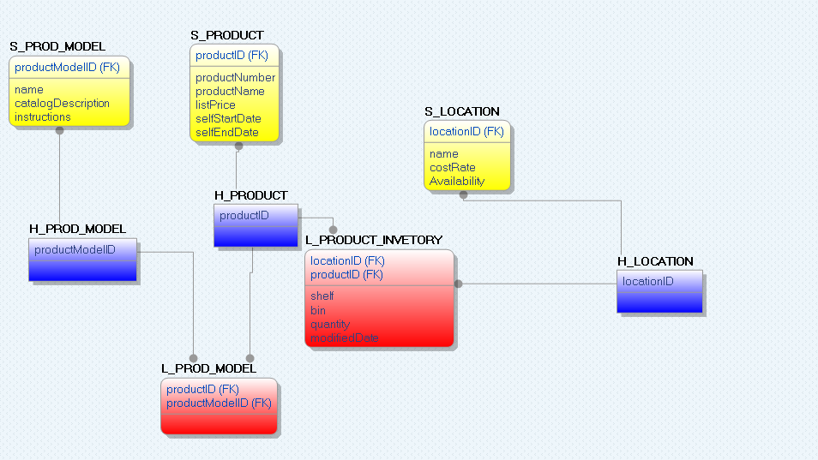

**Logical Model**

*Production Data Mart*

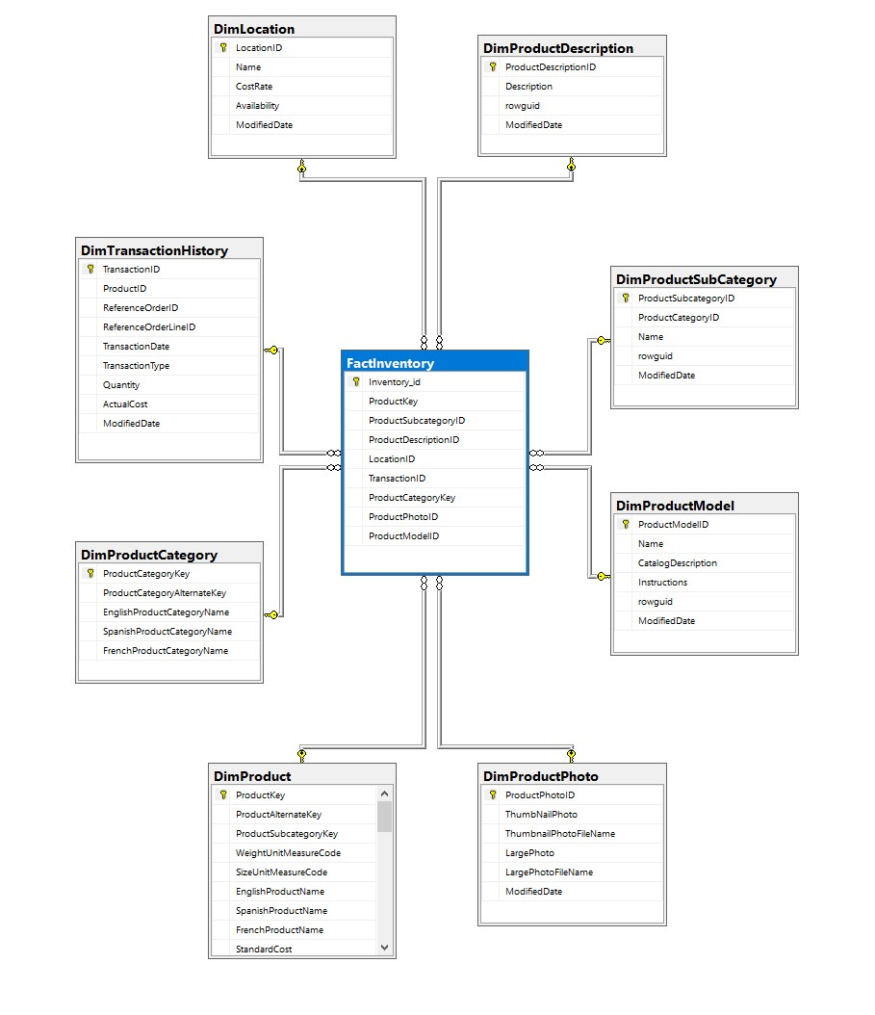

**ETL Process - Production**

1. Makes use of the Audit function to be able to retrieve the machine name, user name, and product ID of each computer that runs a query on the selected source.

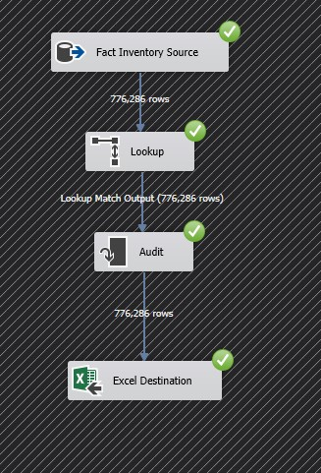

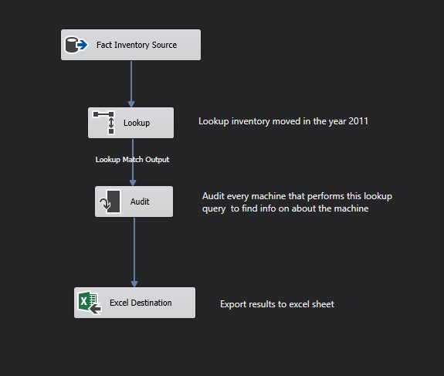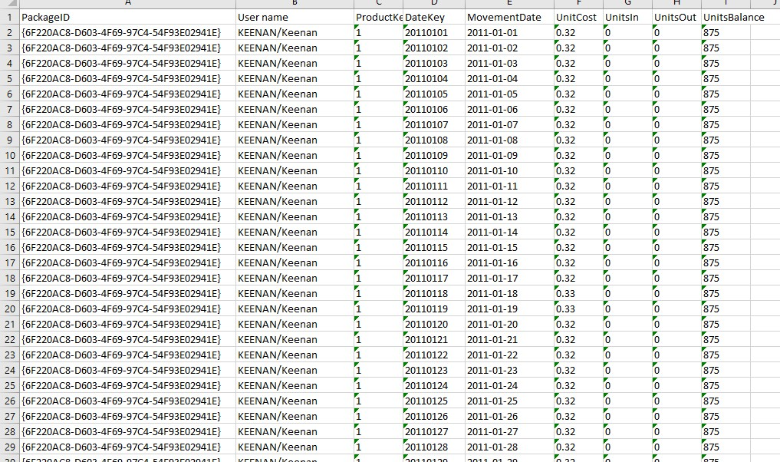

**ETL Process - Production**

2. This diagram makes use of the Aggregate data function of SSIS. This function allows us to find specific, aggregated data, such as “What is the quantity of items on each shelf of inventory, grouped by year?”.

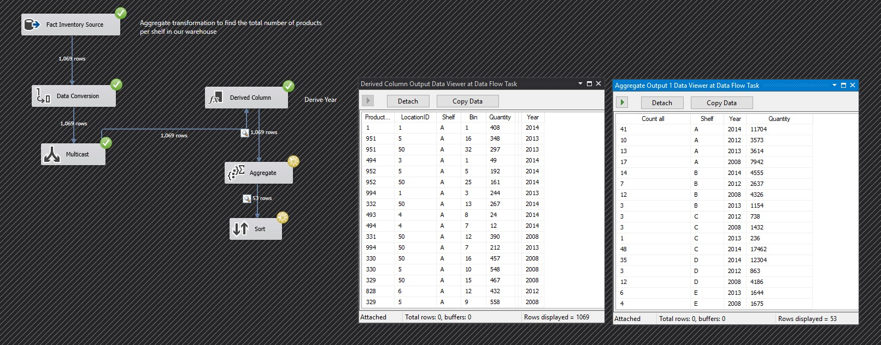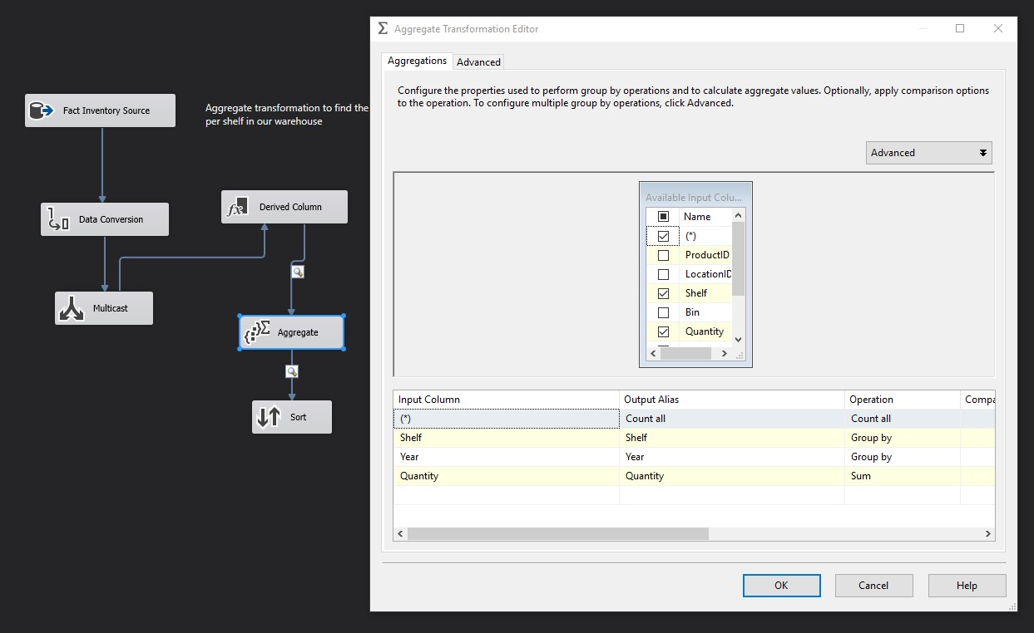

**SQL Queries - Production**

1. **How many products had a product ID between 700 and 800 had a cost less than 6 with the same reference order line?**

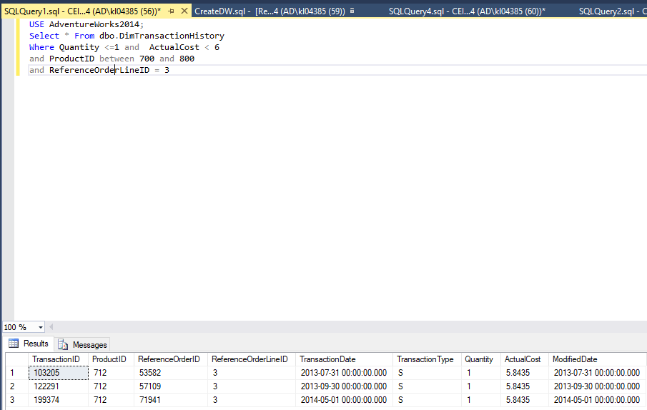

**2) Products with only one finished good flag and a price less than 20**

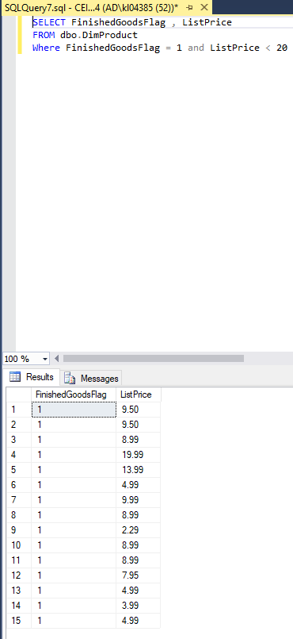

**3. Top 10 percent of products standard cost**

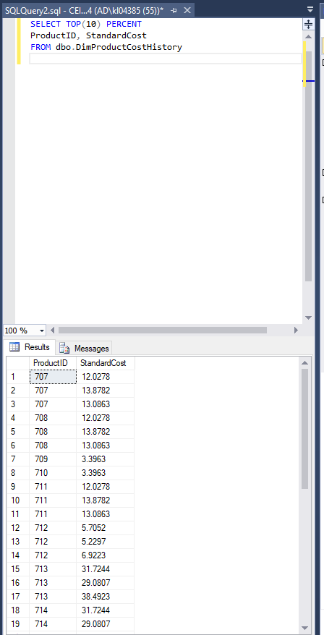

**4. Top 3 percent of work orders with 3 hours of research**

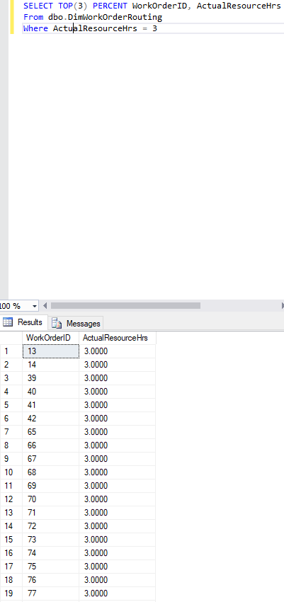

**5. How products have to same quantity during assembly of 2?**

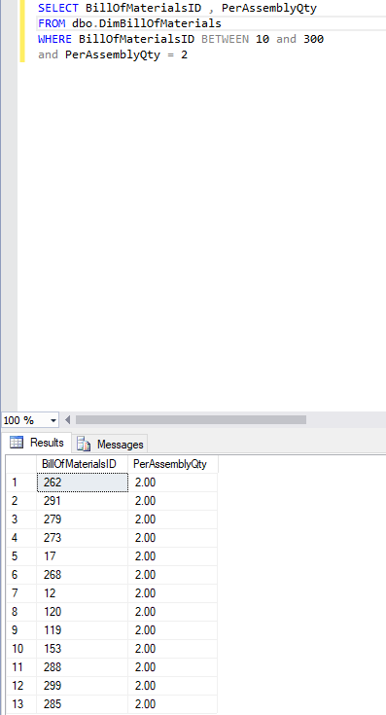

**Human Resources - Chris**

**WIP**

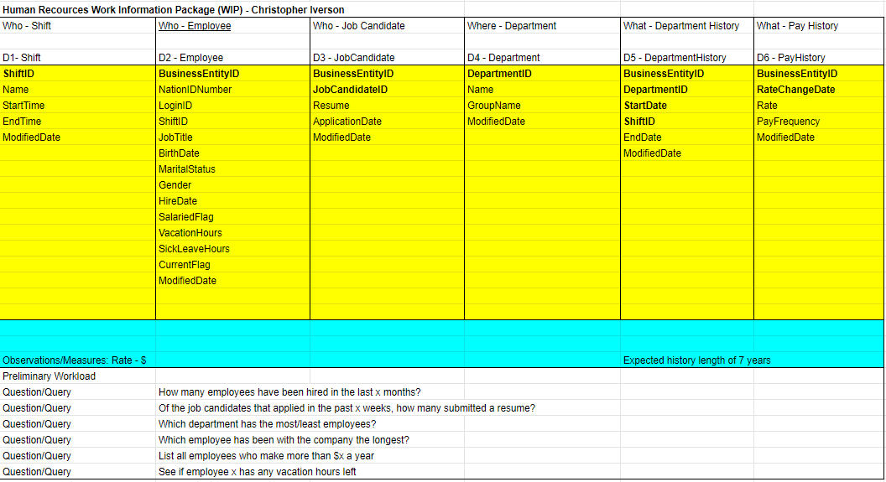

**BEAMS**

*Shift Dimension*

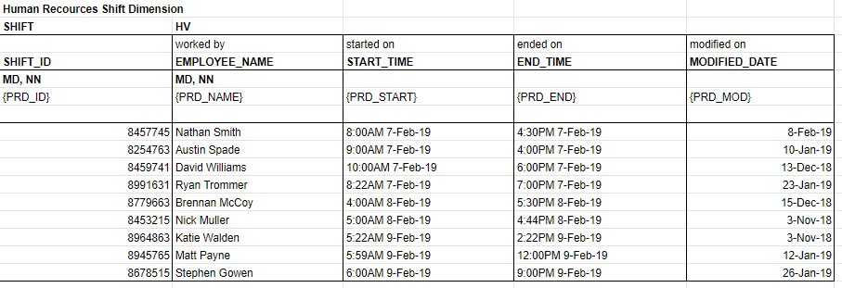

**Data Warehouse Design**

Conceptual Models

Human Resources - Chris

*Dimensional Fact Model*

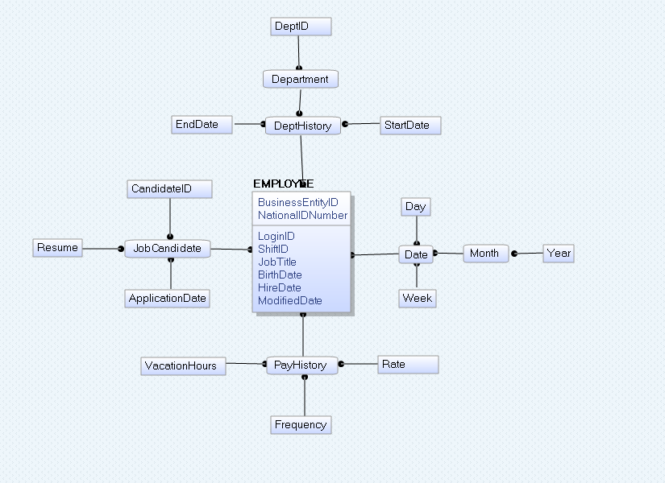

**Logical Model**

*Production Data Mart*

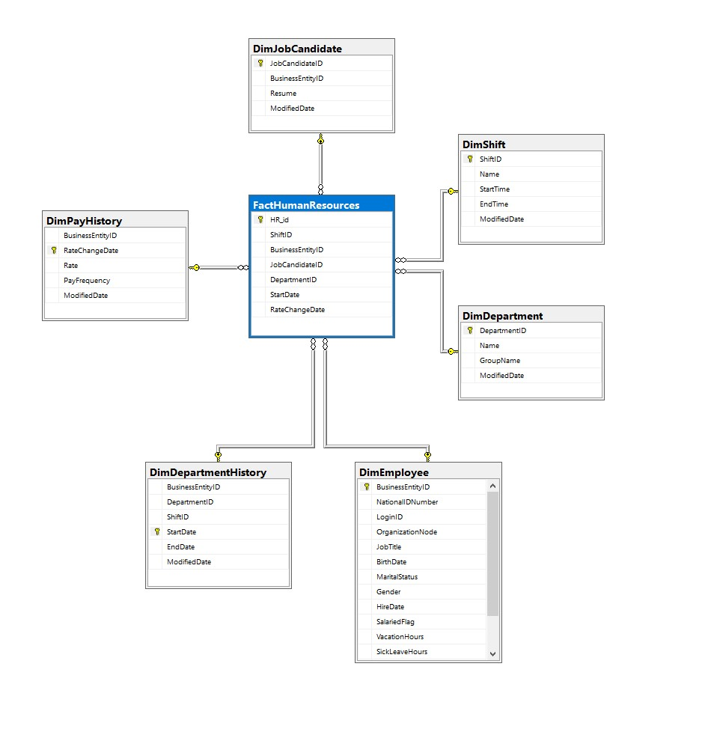

**ETL Process - Human Resources**

1. In this diagram, we show how we can use scripts to validate incoming data. This ensures us that the data we are using is safe, secure, and correct. The script constraints the Gender row to only include ‘M’ and ‘F’ entries, all other throw an error.

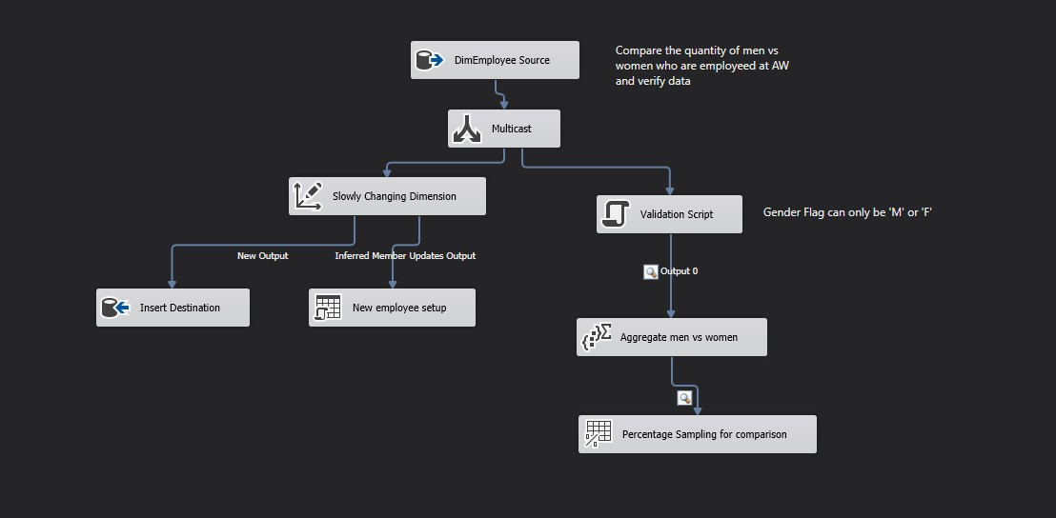

*Setting Gender as a validation row*

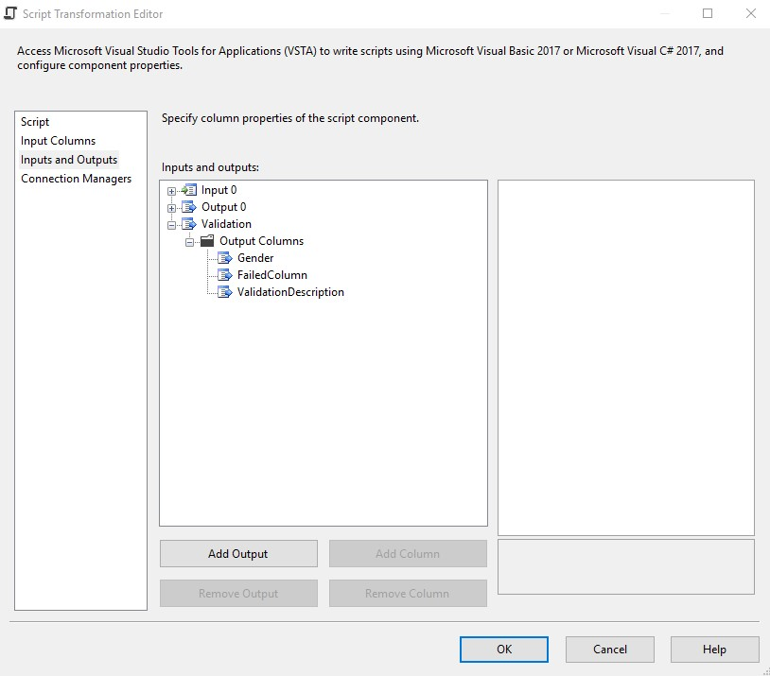

*Script*

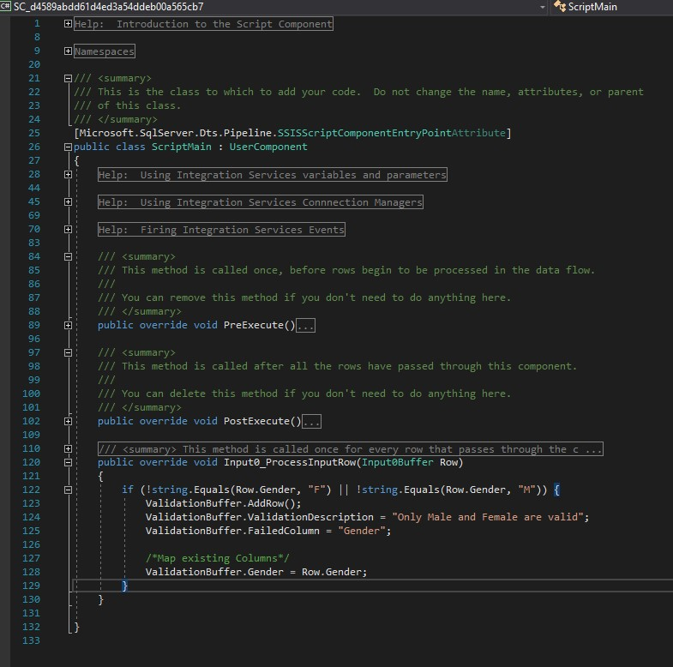

*Data viewer shows us that the script worked successfully and was parsed with aggregate*

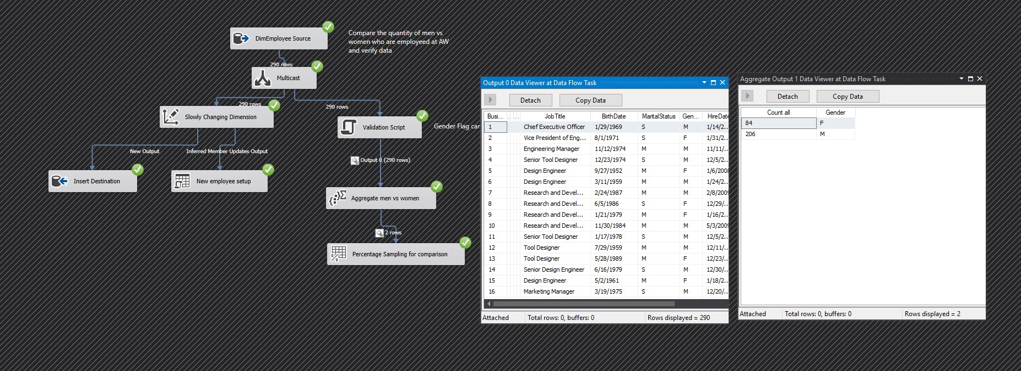

**ETL Process - Human Resources**

2. Shows the full extends of SSIS with exporting and loading data to destination sources

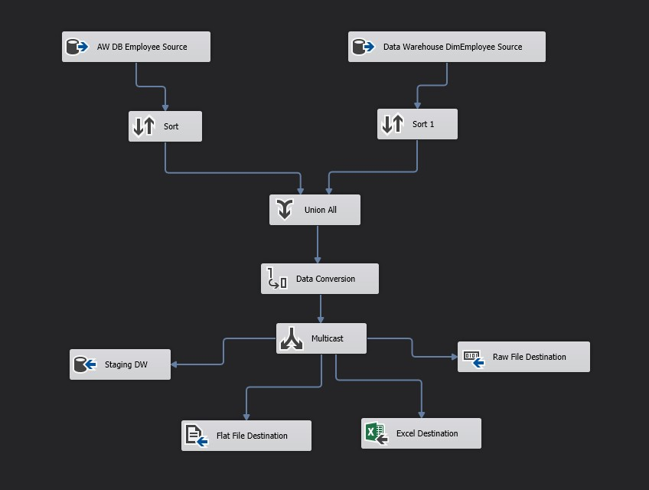

**SQL Queries - Human Resources**

1. Which Employees make more than $12.45 an hour?

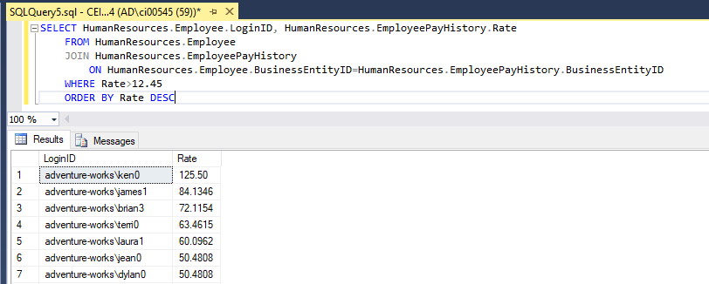

2. Check how many vacation hours and sick leave hours an employee has left

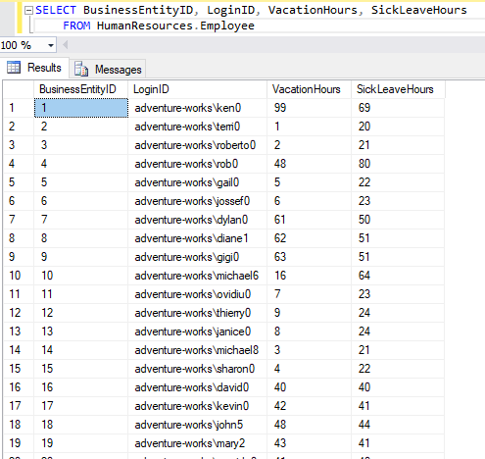

3. Select all Departments in a department Group

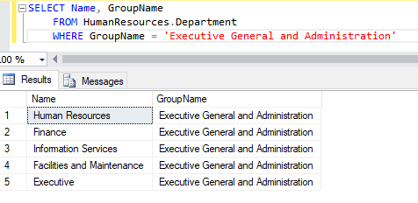

4. How many shifts does each employee currently have scheduled?

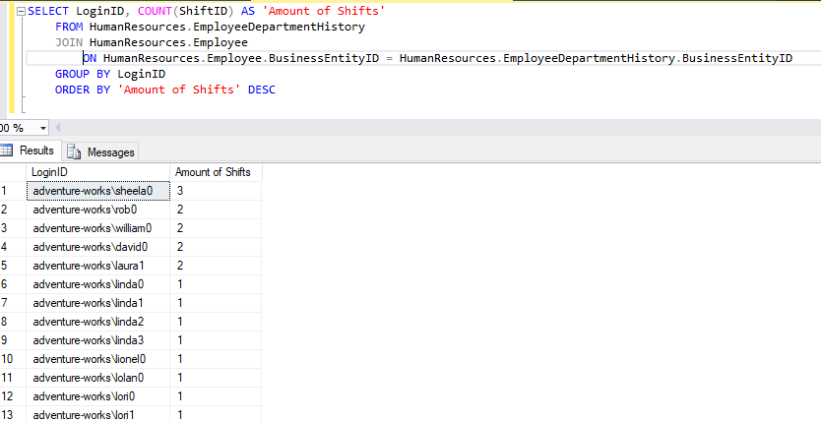

5. Which Departments have the most/least number of employees?

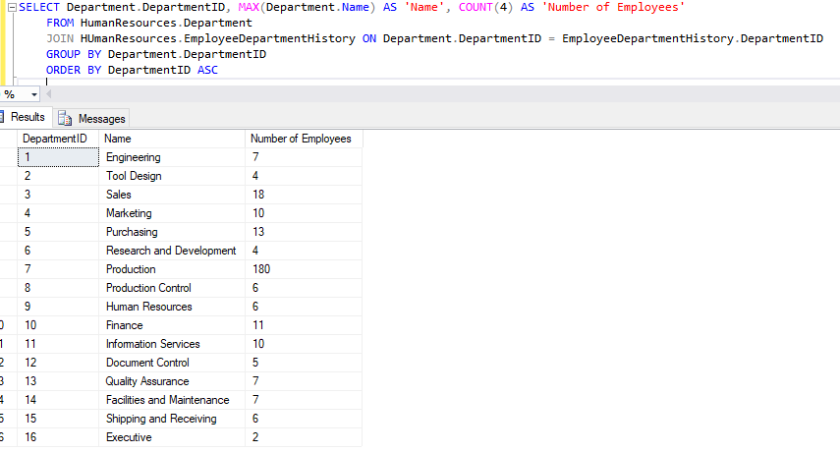

**Purchasing - Wayne**

**WIP**

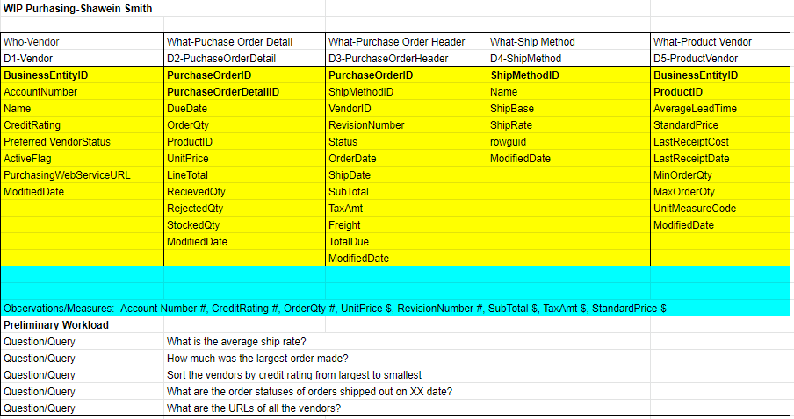

**BEAMS**

*ShipMethod Dimension*

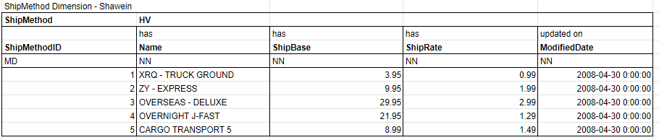

*Vendor Dimension*

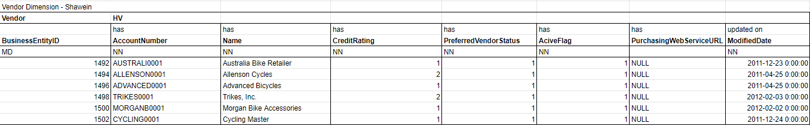

**Data Warehouse Design**

Conceptual Models

Purchasing - Wayne

*Dimensional Fact Model*

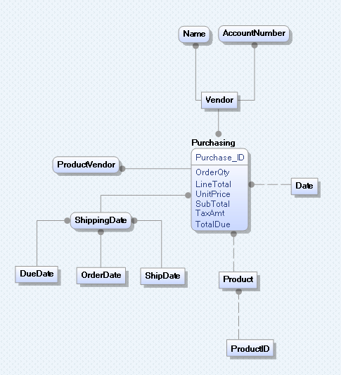

*Data Vault - Purchasing*

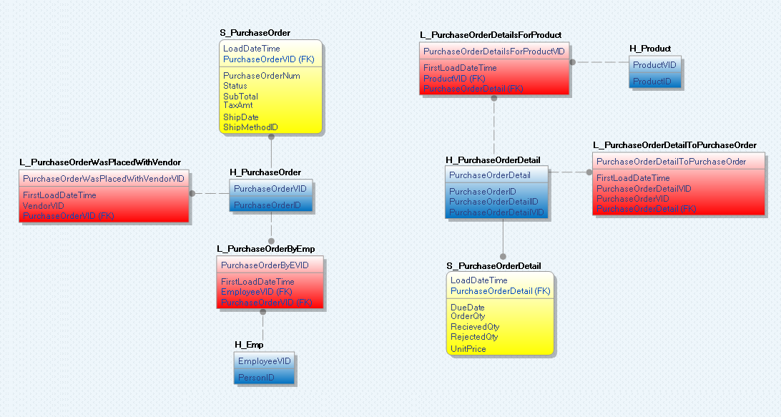

**Conceptual Model**

*Purchasing Data Mart*

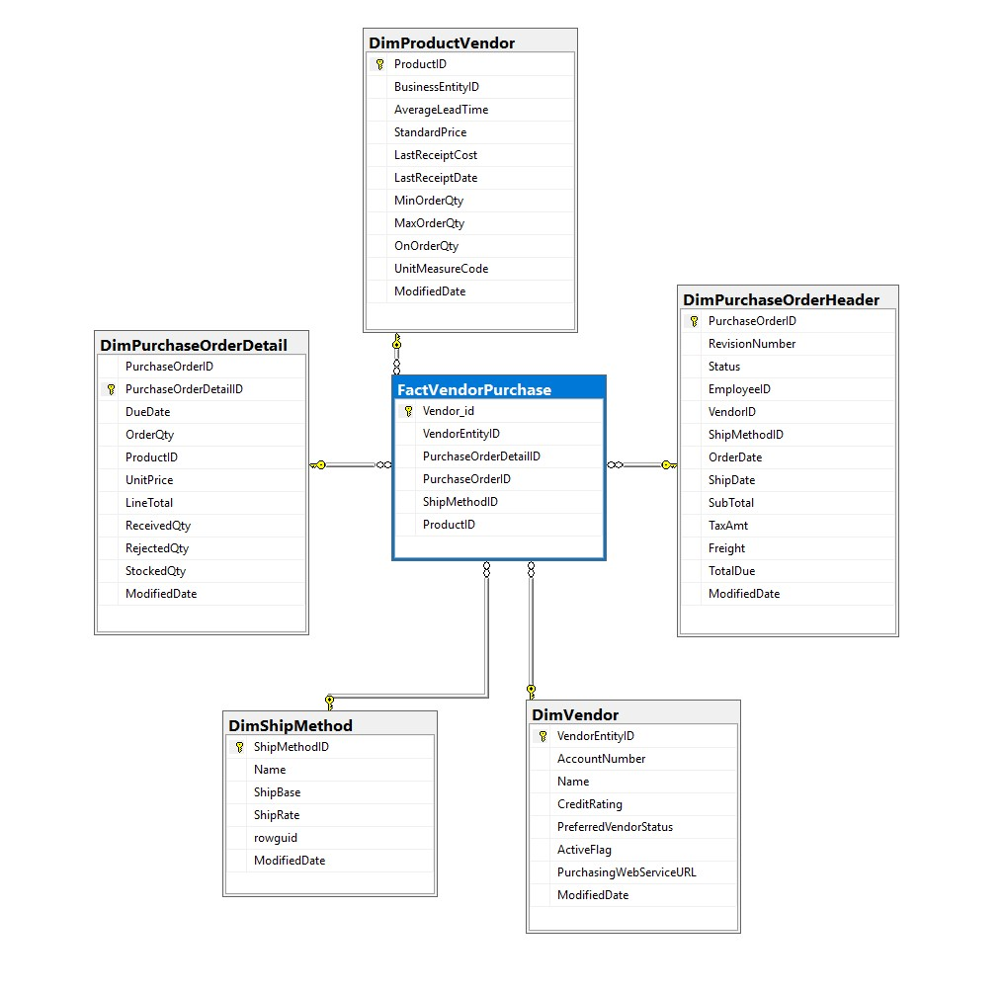

**ETL Process - Purchasing**

1. This diagram shows how SSIS is capable of modeling the flow of a model

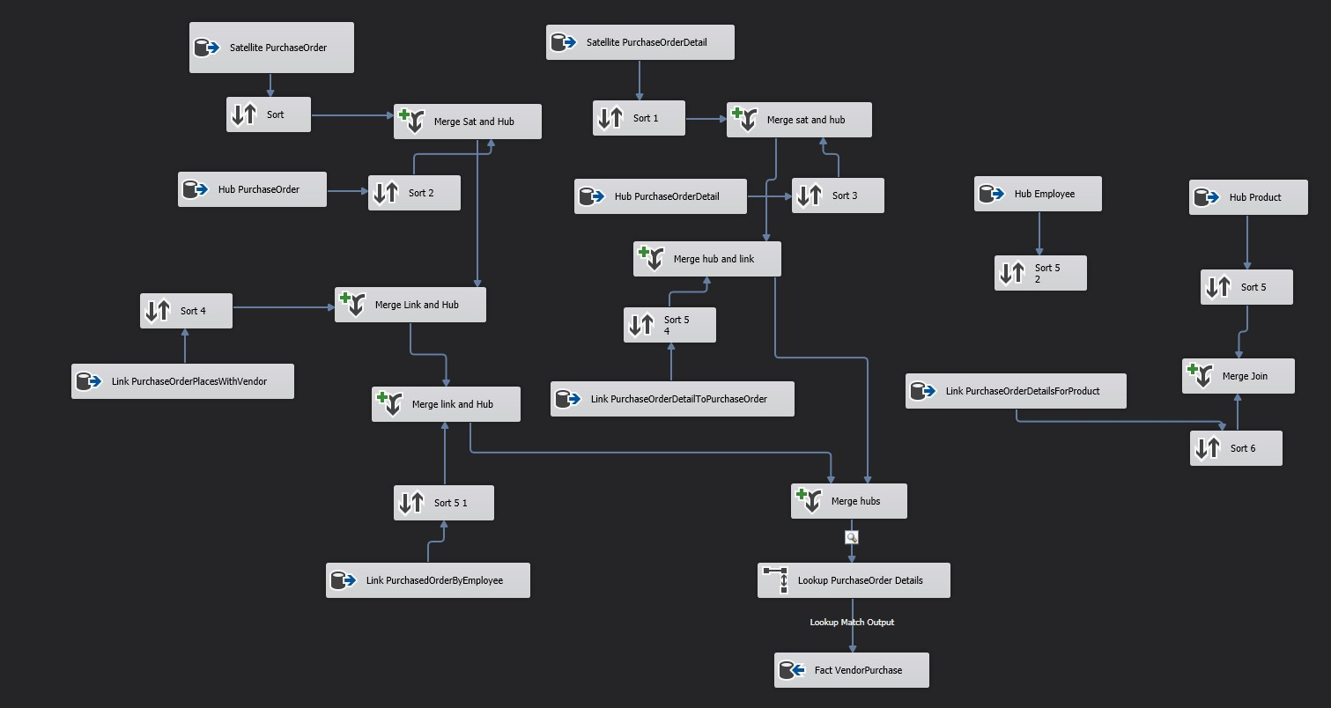

**ETL Process - Purchasing**

2. Shows the ETL process when the destination data source is not connected

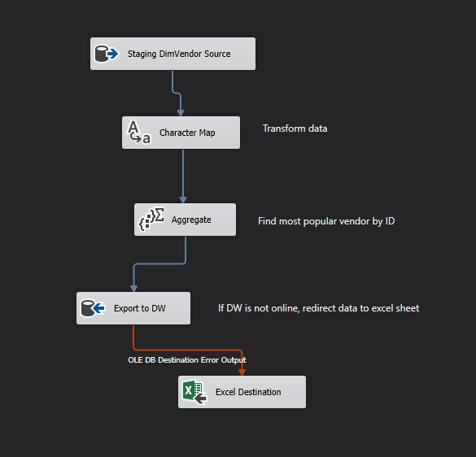

**SQL Queries**

**Closing Remarks**

We have learned an exceptional amount about the inner workings of a data warehouse throughout the course of this semester. The WIP and BEAM tables helped us out an extreme amount when creating our data marts. The logical model was a blessing when it came to helping understand the constraints of our data warehouse. The biggest takeaway from the entire project has to be how powerful a tool like SSIS with Visual Studio is. SSIS holds the power to transform any data into any form you can possibly think of, package it up nicely, and send it anywhere you would like. The skills learned from SSIS can be applied to so many things. The data flow model helped us build the final underlying parts of our data warehouse to give it that final polish.

Being, in Georgia, the demand for data warehousing is skyrocketing currently. The amount of people who know how to run a data warehouse is dwarfed by the growing industry and demand for intelligent data warehousing. The only thing that we would have changed about our project was to add indexing and clusters within our dimensions to make our data warehouse perform better. Overall the performance was average, nothing amazing, but definitely enough to get the job done when it came to ETL. This project really brings the whole course together and adds another notch on the belt of database and data warehouse storage.

**DW Generate Script**

USE [AdventureWorksDW]

GO

/****** Object: Table [dbo].[DimCreditCard] Script Date: 4/27/2019 3:12:28 AM ******/

SET ANSI_NULLS ON

GO

SET QUOTED_IDENTIFIER ON

GO

CREATE TABLE [dbo].[DimCreditCard](

[CreditCardID] [int] IDENTITY(1,1) NOT NULL,

[CardType] [nvarchar](50) NOT NULL,

[CardNumber] [nvarchar](25) NOT NULL,

[ExpMonth] [tinyint] NOT NULL,

[ExpYear] [smallint] NOT NULL,

[ModifiedDate] [datetime] NOT NULL,

CONSTRAINT [PK_CreditCard_CreditCardID] PRIMARY KEY CLUSTERED

(

[CreditCardID] ASC

)WITH (PAD_INDEX = OFF, STATISTICS_NORECOMPUTE = OFF, IGNORE_DUP_KEY = OFF, ALLOW_ROW_LOCKS = ON, ALLOW_PAGE_LOCKS = ON) ON [PRIMARY]

) ON [PRIMARY]

GO

/****** Object: Table [dbo].[DimCustomer] Script Date: 4/27/2019 3:12:28 AM ******/

SET ANSI_NULLS ON

GO

SET QUOTED_IDENTIFIER ON

GO

CREATE TABLE [dbo].[DimCustomer](

[CustomerKey] [int] IDENTITY(1,1) NOT NULL,

[GeographyKey] [int] NULL,

[CustomerAlternateKey] [nvarchar](15) NOT NULL,

[Title] [nvarchar](8) NULL,

[FirstName] [nvarchar](50) NULL,

[MiddleName] [nvarchar](50) NULL,

[LastName] [nvarchar](50) NULL,

[NameStyle] [bit] NULL,

[BirthDate] [date] NULL,

[MaritalStatus] [nchar](1) NULL,

[Suffix] [nvarchar](10) NULL,

[Gender] [nvarchar](1) NULL,

[EmailAddress] [nvarchar](50) NULL,

[YearlyIncome] [money] NULL,

[TotalChildren] [tinyint] NULL,

[NumberChildrenAtHome] [tinyint] NULL,

[EnglishEducation] [nvarchar](40) NULL,

[SpanishEducation] [nvarchar](40) NULL,

[FrenchEducation] [nvarchar](40) NULL,

[EnglishOccupation] [nvarchar](100) NULL,

[SpanishOccupation] [nvarchar](100) NULL,

[FrenchOccupation] [nvarchar](100) NULL,

[HouseOwnerFlag] [nchar](1) NULL,

[NumberCarsOwned] [tinyint] NULL,

[AddressLine1] [nvarchar](120) NULL,

[AddressLine2] [nvarchar](120) NULL,

[Phone] [nvarchar](20) NULL,

[DateFirstPurchase] [date] NULL,

[CommuteDistance] [nvarchar](15) NULL,

CONSTRAINT [PK_DimCustomer_CustomerKey] PRIMARY KEY CLUSTERED

(

[CustomerKey] ASC

)WITH (PAD_INDEX = OFF, STATISTICS_NORECOMPUTE = OFF, IGNORE_DUP_KEY = OFF, ALLOW_ROW_LOCKS = ON, ALLOW_PAGE_LOCKS = ON) ON [PRIMARY]

) ON [PRIMARY]

GO

/****** Object: Table [dbo].[DimDate] Script Date: 4/27/2019 3:12:28 AM ******/

SET ANSI_NULLS ON

GO

SET QUOTED_IDENTIFIER ON

GO

CREATE TABLE [dbo].[DimDate](

[DateKey] [int] NOT NULL,

[FullDateAlternateKey] [date] NOT NULL,

[DayNumberOfWeek] [tinyint] NOT NULL,

[EnglishDayNameOfWeek] [nvarchar](10) NOT NULL,

[SpanishDayNameOfWeek] [nvarchar](10) NOT NULL,

[FrenchDayNameOfWeek] [nvarchar](10) NOT NULL,

[DayNumberOfMonth] [tinyint] NOT NULL,

[DayNumberOfYear] [smallint] NOT NULL,

[WeekNumberOfYear] [tinyint] NOT NULL,

[EnglishMonthName] [nvarchar](10) NOT NULL,

[SpanishMonthName] [nvarchar](10) NOT NULL,

[FrenchMonthName] [nvarchar](10) NOT NULL,

[MonthNumberOfYear] [tinyint] NOT NULL,

[CalendarQuarter] [tinyint] NOT NULL,

[CalendarYear] [smallint] NOT NULL,

[CalendarSemester] [tinyint] NOT NULL,

[FiscalQuarter] [tinyint] NOT NULL,

[FiscalYear] [smallint] NOT NULL,

[FiscalSemester] [tinyint] NOT NULL,

CONSTRAINT [PK_DimDate_DateKey] PRIMARY KEY CLUSTERED

(

[DateKey] ASC

)WITH (PAD_INDEX = OFF, STATISTICS_NORECOMPUTE = OFF, IGNORE_DUP_KEY = OFF, ALLOW_ROW_LOCKS = ON, ALLOW_PAGE_LOCKS = ON) ON [PRIMARY]

) ON [PRIMARY]

GO

/****** Object: Table [dbo].[DimDepartment] Script Date: 4/27/2019 3:12:28 AM ******/

SET ANSI_NULLS ON

GO

SET QUOTED_IDENTIFIER ON

GO

CREATE TABLE [dbo].[DimDepartment](

[DepartmentID] [int] IDENTITY(1,1) NOT NULL,

[Name] [varchar](255) NOT NULL,

[GroupName] [varchar](255) NOT NULL,

[ModifiedDate] [datetime] NOT NULL,

CONSTRAINT [PK_Department_DepartmentID] PRIMARY KEY CLUSTERED

(

[DepartmentID] ASC

)WITH (PAD_INDEX = OFF, STATISTICS_NORECOMPUTE = OFF, IGNORE_DUP_KEY = OFF, ALLOW_ROW_LOCKS = ON, ALLOW_PAGE_LOCKS = ON) ON [PRIMARY]

) ON [PRIMARY]

GO

/****** Object: Table [dbo].[DimDepartmentHistory] Script Date: 4/27/2019 3:12:28 AM ******/

SET ANSI_NULLS ON

GO

SET QUOTED_IDENTIFIER ON

GO

CREATE TABLE [dbo].[DimDepartmentHistory](

[BusinessEntityID] [int] NOT NULL,

[DepartmentID] [int] NOT NULL,

[ShiftID] [int] NOT NULL,

[StartDate] [date] NOT NULL,

[EndDate] [date] NULL,

[ModifiedDate] [datetime] NOT NULL,

CONSTRAINT [PK_StartDate] PRIMARY KEY CLUSTERED

(

[StartDate] ASC

)WITH (PAD_INDEX = OFF, STATISTICS_NORECOMPUTE = OFF, IGNORE_DUP_KEY = OFF, ALLOW_ROW_LOCKS = ON, ALLOW_PAGE_LOCKS = ON) ON [PRIMARY]

) ON [PRIMARY]

GO

/****** Object: Table [dbo].[DimEmployee] Script Date: 4/27/2019 3:12:28 AM ******/

SET ANSI_NULLS ON

GO

SET QUOTED_IDENTIFIER ON

GO

CREATE TABLE [dbo].[DimEmployee](

[BusinessEntityID] [int] NOT NULL,

[NationalIDNumber] [nvarchar](15) NOT NULL,

[LoginID] [nvarchar](256) NOT NULL,

[OrganizationNode] [int] NULL,

[JobTitle] [nvarchar](50) NOT NULL,

[BirthDate] [date] NOT NULL,

[MaritalStatus] [nchar](1) NOT NULL,

[Gender] [nchar](1) NOT NULL,

[HireDate] [date] NOT NULL,

[SalariedFlag] [int] NOT NULL,

[VacationHours] [smallint] NOT NULL,

[SickLeaveHours] [smallint] NOT NULL,

[CurrentFlag] [int] NOT NULL,

[rowguid] [uniqueidentifier] ROWGUIDCOL NOT NULL,

[ModifiedDate] [datetime] NOT NULL,

CONSTRAINT [PK_Employee_BusinessEntityID] PRIMARY KEY CLUSTERED

(

[BusinessEntityID] ASC

)WITH (PAD_INDEX = OFF, STATISTICS_NORECOMPUTE = OFF, IGNORE_DUP_KEY = OFF, ALLOW_ROW_LOCKS = ON, ALLOW_PAGE_LOCKS = ON) ON [PRIMARY]

) ON [PRIMARY]

GO

/****** Object: Table [dbo].[DimJobCandidate] Script Date: 4/27/2019 3:12:28 AM ******/

SET ANSI_NULLS ON

GO

SET QUOTED_IDENTIFIER ON

GO

CREATE TABLE [dbo].[DimJobCandidate](

[JobCandidateID] [int] IDENTITY(1,1) NOT NULL,

[BusinessEntityID] [int] NULL,

[Resume] [varchar](500) NULL,

[ModifiedDate] [datetime] NOT NULL,

CONSTRAINT [PK_JobCandidate_JobCandidateID] PRIMARY KEY CLUSTERED

(

[JobCandidateID] ASC

)WITH (PAD_INDEX = OFF, STATISTICS_NORECOMPUTE = OFF, IGNORE_DUP_KEY = OFF, ALLOW_ROW_LOCKS = ON, ALLOW_PAGE_LOCKS = ON) ON [PRIMARY]

) ON [PRIMARY]

GO

/****** Object: Table [dbo].[DimLocation] Script Date: 4/27/2019 3:12:28 AM ******/

SET ANSI_NULLS ON

GO

SET QUOTED_IDENTIFIER ON

GO

CREATE TABLE [dbo].[DimLocation](

[LocationID] [int] IDENTITY(1,1) NOT NULL,

[Name] [varchar](255) NOT NULL,

[CostRate] [smallmoney] NOT NULL,

[Availability] [decimal](8, 2) NOT NULL,

[ModifiedDate] [datetime] NOT NULL,

CONSTRAINT [PK_Location_LocationID] PRIMARY KEY CLUSTERED

(

[LocationID] ASC

)WITH (PAD_INDEX = OFF, STATISTICS_NORECOMPUTE = OFF, IGNORE_DUP_KEY = OFF, ALLOW_ROW_LOCKS = ON, ALLOW_PAGE_LOCKS = ON) ON [PRIMARY]

) ON [PRIMARY]

GO

/****** Object: Table [dbo].[DimPayHistory] Script Date: 4/27/2019 3:12:28 AM ******/

SET ANSI_NULLS ON

GO

SET QUOTED_IDENTIFIER ON

GO

CREATE TABLE [dbo].[DimPayHistory](

[BusinessEntityID] [int] NOT NULL,

[RateChangeDate] [datetime] NOT NULL,

[Rate] [money] NOT NULL,

[PayFrequency] [tinyint] NOT NULL,

[ModifiedDate] [datetime] NOT NULL,

CONSTRAINT [PK_EmployeePayHistory_RateChangeDate] PRIMARY KEY CLUSTERED

(

[RateChangeDate] ASC

)WITH (PAD_INDEX = OFF, STATISTICS_NORECOMPUTE = OFF, IGNORE_DUP_KEY = OFF, ALLOW_ROW_LOCKS = ON, ALLOW_PAGE_LOCKS = ON) ON [PRIMARY]

) ON [PRIMARY]

GO

/****** Object: Table [dbo].[DimProduct] Script Date: 4/27/2019 3:12:28 AM ******/

SET ANSI_NULLS ON

GO

SET QUOTED_IDENTIFIER ON

GO

CREATE TABLE [dbo].[DimProduct](

[ProductKey] [int] IDENTITY(1,1) NOT NULL,

[ProductAlternateKey] [nvarchar](25) NULL,

[ProductSubcategoryKey] [int] NULL,

[WeightUnitMeasureCode] [nchar](3) NULL,

[SizeUnitMeasureCode] [nchar](3) NULL,

[EnglishProductName] [nvarchar](50) NOT NULL,

[SpanishProductName] [nvarchar](50) NOT NULL,

[FrenchProductName] [nvarchar](50) NOT NULL,

[StandardCost] [money] NULL,

[FinishedGoodsFlag] [bit] NOT NULL,

[Color] [nvarchar](15) NOT NULL,

[SafetyStockLevel] [smallint] NULL,

[ReorderPoint] [smallint] NULL,

[ListPrice] [money] NULL,

[Size] [nvarchar](50) NULL,

[SizeRange] [nvarchar](50) NULL,

[Weight] [float] NULL,

[DaysToManufacture] [int] NULL,

[ProductLine] [nchar](2) NULL,

[DealerPrice] [money] NULL,

[Class] [nchar](2) NULL,

[Style] [nchar](2) NULL,

[ModelName] [nvarchar](50) NULL,

[LargePhoto] [varbinary](max) NULL,

[EnglishDescription] [nvarchar](400) NULL,

[FrenchDescription] [nvarchar](400) NULL,

[ChineseDescription] [nvarchar](400) NULL,

[ArabicDescription] [nvarchar](400) NULL,

[HebrewDescription] [nvarchar](400) NULL,

[ThaiDescription] [nvarchar](400) NULL,

[GermanDescription] [nvarchar](400) NULL,

[JapaneseDescription] [nvarchar](400) NULL,

[TurkishDescription] [nvarchar](400) NULL,

[StartDate] [datetime] NULL,

[EndDate] [datetime] NULL,

[Status] [nvarchar](7) NULL,

CONSTRAINT [PK_DimProduct_ProductKey] PRIMARY KEY CLUSTERED

(

[ProductKey] ASC

)WITH (PAD_INDEX = OFF, STATISTICS_NORECOMPUTE = OFF, IGNORE_DUP_KEY = OFF, ALLOW_ROW_LOCKS = ON, ALLOW_PAGE_LOCKS = ON) ON [PRIMARY],

CONSTRAINT [AK_DimProduct_ProductAlternateKey_StartDate] UNIQUE NONCLUSTERED

(

[ProductAlternateKey] ASC,

[StartDate] ASC

)WITH (PAD_INDEX = OFF, STATISTICS_NORECOMPUTE = OFF, IGNORE_DUP_KEY = OFF, ALLOW_ROW_LOCKS = ON, ALLOW_PAGE_LOCKS = ON) ON [PRIMARY]

) ON [PRIMARY] TEXTIMAGE_ON [PRIMARY]

GO

/****** Object: Table [dbo].[DimProductCategory] Script Date: 4/27/2019 3:12:28 AM ******/

SET ANSI_NULLS ON

GO

SET QUOTED_IDENTIFIER ON

GO

CREATE TABLE [dbo].[DimProductCategory](

[ProductCategoryKey] [int] IDENTITY(1,1) NOT NULL,

[ProductCategoryAlternateKey] [int] NULL,

[EnglishProductCategoryName] [nvarchar](50) NOT NULL,

[SpanishProductCategoryName] [nvarchar](50) NOT NULL,

[FrenchProductCategoryName] [nvarchar](50) NOT NULL,

CONSTRAINT [PK_DimProductCategory_ProductCategoryKey] PRIMARY KEY CLUSTERED

(

[ProductCategoryKey] ASC

)WITH (PAD_INDEX = OFF, STATISTICS_NORECOMPUTE = OFF, IGNORE_DUP_KEY = OFF, ALLOW_ROW_LOCKS = ON, ALLOW_PAGE_LOCKS = ON) ON [PRIMARY],

CONSTRAINT [AK_DimProductCategory_ProductCategoryAlternateKey] UNIQUE NONCLUSTERED

(

[ProductCategoryAlternateKey] ASC

)WITH (PAD_INDEX = OFF, STATISTICS_NORECOMPUTE = OFF, IGNORE_DUP_KEY = OFF, ALLOW_ROW_LOCKS = ON, ALLOW_PAGE_LOCKS = ON) ON [PRIMARY]

) ON [PRIMARY]

GO

/****** Object: Table [dbo].[DimProductDescription] Script Date: 4/27/2019 3:12:28 AM ******/

SET ANSI_NULLS ON

GO

SET QUOTED_IDENTIFIER ON

GO

CREATE TABLE [dbo].[DimProductDescription](

[ProductDescriptionID] [int] IDENTITY(1,1) NOT NULL,

[Description] [nvarchar](400) NOT NULL,

[rowguid] [uniqueidentifier] ROWGUIDCOL NOT NULL,

[ModifiedDate] [datetime] NOT NULL,

CONSTRAINT [PK_ProductDescription_ProductDescriptionID] PRIMARY KEY CLUSTERED

(

[ProductDescriptionID] ASC

)WITH (PAD_INDEX = OFF, STATISTICS_NORECOMPUTE = OFF, IGNORE_DUP_KEY = OFF, ALLOW_ROW_LOCKS = ON, ALLOW_PAGE_LOCKS = ON) ON [PRIMARY]

) ON [PRIMARY]

GO

/****** Object: Table [dbo].[DimProductModel] Script Date: 4/27/2019 3:12:29 AM ******/

SET ANSI_NULLS ON

GO

SET QUOTED_IDENTIFIER ON

GO

CREATE TABLE [dbo].[DimProductModel](

[ProductModelID] [int] IDENTITY(1,1) NOT NULL,

[Name] [varchar](255) NOT NULL,

[CatalogDescription] [varchar](500) NULL,

[Instructions] [varchar](500) NULL,

[rowguid] [uniqueidentifier] ROWGUIDCOL NOT NULL,

[ModifiedDate] [datetime] NOT NULL,

CONSTRAINT [PK_ProductModel_ProductModelID] PRIMARY KEY CLUSTERED

(

[ProductModelID] ASC

)WITH (PAD_INDEX = OFF, STATISTICS_NORECOMPUTE = OFF, IGNORE_DUP_KEY = OFF, ALLOW_ROW_LOCKS = ON, ALLOW_PAGE_LOCKS = ON) ON [PRIMARY]

) ON [PRIMARY]

GO

/****** Object: Table [dbo].[DimProductPhoto] Script Date: 4/27/2019 3:12:29 AM ******/

SET ANSI_NULLS ON

GO

SET QUOTED_IDENTIFIER ON

GO

CREATE TABLE [dbo].[DimProductPhoto](

[ProductPhotoID] [int] IDENTITY(1,1) NOT NULL,

[ThumbNailPhoto] [varbinary](max) NULL,

[ThumbnailPhotoFileName] [nvarchar](50) NULL,

[LargePhoto] [varbinary](max) NULL,

[LargePhotoFileName] [nvarchar](50) NULL,

[ModifiedDate] [datetime] NOT NULL,

CONSTRAINT [PK_ProductPhoto_ProductPhotoID] PRIMARY KEY CLUSTERED

(

[ProductPhotoID] ASC

)WITH (PAD_INDEX = OFF, STATISTICS_NORECOMPUTE = OFF, IGNORE_DUP_KEY = OFF, ALLOW_ROW_LOCKS = ON, ALLOW_PAGE_LOCKS = ON) ON [PRIMARY]

) ON [PRIMARY] TEXTIMAGE_ON [PRIMARY]

GO

/****** Object: Table [dbo].[DimProductSubCategory] Script Date: 4/27/2019 3:12:29 AM ******/

SET ANSI_NULLS ON

GO

SET QUOTED_IDENTIFIER ON

GO

CREATE TABLE [dbo].[DimProductSubCategory](

[ProductSubcategoryID] [int] IDENTITY(1,1) NOT NULL,

[ProductCategoryID] [int] NOT NULL,

[Name] [varchar](255) NOT NULL,

[rowguid] [uniqueidentifier] ROWGUIDCOL NOT NULL,

[ModifiedDate] [datetime] NOT NULL,

CONSTRAINT [PK_ProductSubcategory_ProductSubcategoryID] PRIMARY KEY CLUSTERED

(

[ProductSubcategoryID] ASC

)WITH (PAD_INDEX = OFF, STATISTICS_NORECOMPUTE = OFF, IGNORE_DUP_KEY = OFF, ALLOW_ROW_LOCKS = ON, ALLOW_PAGE_LOCKS = ON) ON [PRIMARY]

) ON [PRIMARY]

GO

/****** Object: Table [dbo].[DimProductVendor] Script Date: 4/27/2019 3:12:29 AM ******/

SET ANSI_NULLS ON

GO

SET QUOTED_IDENTIFIER ON

GO

CREATE TABLE [dbo].[DimProductVendor](

[ProductID] [int] NOT NULL,

[BusinessEntityID] [int] NOT NULL,

[AverageLeadTime] [int] NOT NULL,

[StandardPrice] [money] NOT NULL,

[LastReceiptCost] [money] NULL,

[LastReceiptDate] [datetime] NULL,

[MinOrderQty] [int] NOT NULL,

[MaxOrderQty] [int] NOT NULL,

[OnOrderQty] [int] NULL,

[UnitMeasureCode] [nchar](3) NOT NULL,

[ModifiedDate] [datetime] NOT NULL,

CONSTRAINT [PK_ProductVendor_ProductID] PRIMARY KEY CLUSTERED

(

[ProductID] ASC

)WITH (PAD_INDEX = OFF, STATISTICS_NORECOMPUTE = OFF, IGNORE_DUP_KEY = OFF, ALLOW_ROW_LOCKS = ON, ALLOW_PAGE_LOCKS = ON) ON [PRIMARY]

) ON [PRIMARY]

GO

/****** Object: Table [dbo].[DimPurchaseOrderDetail] Script Date: 4/27/2019 3:12:29 AM ******/

SET ANSI_NULLS ON

GO

SET QUOTED_IDENTIFIER ON

GO

CREATE TABLE [dbo].[DimPurchaseOrderDetail](

[PurchaseOrderID] [int] NOT NULL,

[PurchaseOrderDetailID] [int] IDENTITY(1,1) NOT NULL,

[DueDate] [datetime] NOT NULL,

[OrderQty] [smallint] NOT NULL,

[ProductID] [int] NOT NULL,

[UnitPrice] [money] NOT NULL,

[LineTotal] AS (isnull([OrderQty]*[UnitPrice],(0.00))),

[ReceivedQty] [decimal](8, 2) NOT NULL,

[RejectedQty] [decimal](8, 2) NOT NULL,

[StockedQty] AS (isnull([ReceivedQty]-[RejectedQty],(0.00))),

[ModifiedDate] [datetime] NOT NULL,

CONSTRAINT [PK_PurchaseOrderDetail_PurchaseOrderDetailID] PRIMARY KEY CLUSTERED

(

[PurchaseOrderDetailID] ASC

)WITH (PAD_INDEX = OFF, STATISTICS_NORECOMPUTE = OFF, IGNORE_DUP_KEY = OFF, ALLOW_ROW_LOCKS = ON, ALLOW_PAGE_LOCKS = ON) ON [PRIMARY]

) ON [PRIMARY]

GO

/****** Object: Table [dbo].[DimPurchaseOrderHeader] Script Date: 4/27/2019 3:12:29 AM ******/

SET ANSI_NULLS ON

GO

SET QUOTED_IDENTIFIER ON

GO

CREATE TABLE [dbo].[DimPurchaseOrderHeader](

[PurchaseOrderID] [int] IDENTITY(1,1) NOT NULL,

[RevisionNumber] [tinyint] NOT NULL,

[Status] [tinyint] NOT NULL,

[EmployeeID] [int] NOT NULL,

[VendorID] [int] NOT NULL,

[ShipMethodID] [int] NOT NULL,

[OrderDate] [datetime] NOT NULL,

[ShipDate] [datetime] NULL,

[SubTotal] [money] NOT NULL,

[TaxAmt] [money] NOT NULL,

[Freight] [money] NOT NULL,

[TotalDue] AS (isnull(([SubTotal]+[TaxAmt])+[Freight],(0))) PERSISTED NOT NULL,

[ModifiedDate] [datetime] NOT NULL,

CONSTRAINT [PK_PurchaseOrderHeader_PurchaseOrderID] PRIMARY KEY CLUSTERED

(

[PurchaseOrderID] ASC

)WITH (PAD_INDEX = OFF, STATISTICS_NORECOMPUTE = OFF, IGNORE_DUP_KEY = OFF, ALLOW_ROW_LOCKS = ON, ALLOW_PAGE_LOCKS = ON) ON [PRIMARY]

) ON [PRIMARY]

GO

/****** Object: Table [dbo].[DimSalesPerson] Script Date: 4/27/2019 3:12:29 AM ******/

SET ANSI_NULLS ON

GO

SET QUOTED_IDENTIFIER ON

GO

CREATE TABLE [dbo].[DimSalesPerson](

[SalesPerson_id] [int] IDENTITY(1,1) NOT NULL,

[FirstName] [varchar](255) NULL,

[LastName] [varchar](255) NULL,

[JobTitle] [varchar](255) NULL,

[gender] [varchar](255) NULL,

[HiringDate] [int] NULL,

[BirthDate] [int] NULL,

[SalesPersonKey] [int] NULL,

PRIMARY KEY CLUSTERED

(

[SalesPerson_id] ASC

)WITH (PAD_INDEX = OFF, STATISTICS_NORECOMPUTE = OFF, IGNORE_DUP_KEY = OFF, ALLOW_ROW_LOCKS = ON, ALLOW_PAGE_LOCKS = ON) ON [PRIMARY]

) ON [PRIMARY]

GO

/****** Object: Table [dbo].[DimSalesTerritory] Script Date: 4/27/2019 3:12:29 AM ******/

SET ANSI_NULLS ON

GO

SET QUOTED_IDENTIFIER ON

GO

CREATE TABLE [dbo].[DimSalesTerritory](

[SalesTerritoryKey] [int] IDENTITY(1,1) NOT NULL,

[SalesTerritoryAlternateKey] [int] NULL,

[SalesTerritoryRegion] [nvarchar](50) NOT NULL,

[SalesTerritoryCountry] [nvarchar](50) NOT NULL,

[SalesTerritoryGroup] [nvarchar](50) NULL,

[SalesTerritoryImage] [varbinary](max) NULL,

CONSTRAINT [PK_DimSalesTerritory_SalesTerritoryKey] PRIMARY KEY CLUSTERED

(

[SalesTerritoryKey] ASC

)WITH (PAD_INDEX = OFF, STATISTICS_NORECOMPUTE = OFF, IGNORE_DUP_KEY = OFF, ALLOW_ROW_LOCKS = ON, ALLOW_PAGE_LOCKS = ON) ON [PRIMARY],

CONSTRAINT [AK_DimSalesTerritory_SalesTerritoryAlternateKey] UNIQUE NONCLUSTERED

(

[SalesTerritoryAlternateKey] ASC

)WITH (PAD_INDEX = OFF, STATISTICS_NORECOMPUTE = OFF, IGNORE_DUP_KEY = OFF, ALLOW_ROW_LOCKS = ON, ALLOW_PAGE_LOCKS = ON) ON [PRIMARY]

) ON [PRIMARY] TEXTIMAGE_ON [PRIMARY]

GO

/****** Object: Table [dbo].[DimShift] Script Date: 4/27/2019 3:12:29 AM ******/

SET ANSI_NULLS ON

GO

SET QUOTED_IDENTIFIER ON

GO

CREATE TABLE [dbo].[DimShift](

[ShiftID] [int] IDENTITY(1,1) NOT NULL,

[Name] [varchar](255) NOT NULL,

[StartTime] [time](7) NOT NULL,

[EndTime] [time](7) NOT NULL,

[ModifiedDate] [datetime] NOT NULL,

CONSTRAINT [PK_Shift_ShiftID] PRIMARY KEY CLUSTERED

(

[ShiftID] ASC

)WITH (PAD_INDEX = OFF, STATISTICS_NORECOMPUTE = OFF, IGNORE_DUP_KEY = OFF, ALLOW_ROW_LOCKS = ON, ALLOW_PAGE_LOCKS = ON) ON [PRIMARY]

) ON [PRIMARY]

GO

/****** Object: Table [dbo].[DimShipMethod] Script Date: 4/27/2019 3:12:29 AM ******/

SET ANSI_NULLS ON

GO

SET QUOTED_IDENTIFIER ON

GO

CREATE TABLE [dbo].[DimShipMethod](

[ShipMethodID] [int] IDENTITY(1,1) NOT NULL,

[Name] [varchar](255) NOT NULL,

[ShipBase] [money] NOT NULL,

[ShipRate] [money] NOT NULL,

[rowguid] [uniqueidentifier] ROWGUIDCOL NOT NULL,

[ModifiedDate] [datetime] NOT NULL,

CONSTRAINT [PK_ShipMethod_ShipMethodID] PRIMARY KEY CLUSTERED

(

[ShipMethodID] ASC

)WITH (PAD_INDEX = OFF, STATISTICS_NORECOMPUTE = OFF, IGNORE_DUP_KEY = OFF, ALLOW_ROW_LOCKS = ON, ALLOW_PAGE_LOCKS = ON) ON [PRIMARY]

) ON [PRIMARY]

GO

/****** Object: Table [dbo].[DimTransactionHistory] Script Date: 4/27/2019 3:12:29 AM ******/

SET ANSI_NULLS ON

GO

SET QUOTED_IDENTIFIER ON

GO

CREATE TABLE [dbo].[DimTransactionHistory](

[TransactionID] [int] IDENTITY(100000,1) NOT NULL,

[ProductID] [int] NOT NULL,

[ReferenceOrderID] [int] NOT NULL,

[ReferenceOrderLineID] [int] NOT NULL,

[TransactionDate] [datetime] NOT NULL,

[TransactionType] [nchar](1) NOT NULL,

[Quantity] [int] NOT NULL,

[ActualCost] [money] NOT NULL,

[ModifiedDate] [datetime] NOT NULL,

CONSTRAINT [PK_TransactionHistory_TransactionID] PRIMARY KEY CLUSTERED

(

[TransactionID] ASC

)WITH (PAD_INDEX = OFF, STATISTICS_NORECOMPUTE = OFF, IGNORE_DUP_KEY = OFF, ALLOW_ROW_LOCKS = ON, ALLOW_PAGE_LOCKS = ON) ON [PRIMARY]

) ON [PRIMARY]

GO

/****** Object: Table [dbo].[DimVendor] Script Date: 4/27/2019 3:12:29 AM ******/

SET ANSI_NULLS ON

GO

SET QUOTED_IDENTIFIER ON

GO

CREATE TABLE [dbo].[DimVendor](

[VendorEntityID] [int] NOT NULL,

[AccountNumber] [int] NOT NULL,

[Name] [varchar](255) NOT NULL,

[CreditRating] [tinyint] NOT NULL,

[PreferredVendorStatus] [varchar](255) NOT NULL,

[ActiveFlag] [varchar](255) NOT NULL,

[PurchasingWebServiceURL] [nvarchar](1024) NULL,

[ModifiedDate] [datetime] NOT NULL,

CONSTRAINT [PK_Vendor_VendorEntityID] PRIMARY KEY CLUSTERED

(

[VendorEntityID] ASC

)WITH (PAD_INDEX = OFF, STATISTICS_NORECOMPUTE = OFF, IGNORE_DUP_KEY = OFF, ALLOW_ROW_LOCKS = ON, ALLOW_PAGE_LOCKS = ON) ON [PRIMARY]

) ON [PRIMARY]

GO

/****** Object: Table [dbo].[FactHumanResources] Script Date: 4/27/2019 3:12:29 AM ******/

SET ANSI_NULLS ON

GO

SET QUOTED_IDENTIFIER ON

GO

CREATE TABLE [dbo].[FactHumanResources](

[HR_id] [int] IDENTITY(1,1) NOT NULL,

[ShiftID] [int] NULL,

[BusinessEntityID] [int] NULL,

[JobCandidateID] [int] NULL,

[DepartmentID] [int] NULL,

[StartDate] [date] NULL,

[RateChangeDate] [datetime] NULL,

PRIMARY KEY CLUSTERED

(

[HR_id] ASC

)WITH (PAD_INDEX = OFF, STATISTICS_NORECOMPUTE = OFF, IGNORE_DUP_KEY = OFF, ALLOW_ROW_LOCKS = ON, ALLOW_PAGE_LOCKS = ON) ON [PRIMARY]

) ON [PRIMARY]

GO

/****** Object: Table [dbo].[FactInventory] Script Date: 4/27/2019 3:12:29 AM ******/

SET ANSI_NULLS ON

GO

SET QUOTED_IDENTIFIER ON

GO

CREATE TABLE [dbo].[FactInventory](

[Inventory_id] [int] IDENTITY(1,1) NOT NULL,

[ProductKey] [int] NULL,

[ProductSubcategoryID] [int] NULL,

[ProductDescriptionID] [int] NULL,

[LocationID] [int] NULL,

[TransactionID] [int] NULL,

[ProductCategoryKey] [int] NULL,

[ProductPhotoID] [int] NULL,

[ProductModelID] [int] NULL,

PRIMARY KEY CLUSTERED

(

[Inventory_id] ASC

)WITH (PAD_INDEX = OFF, STATISTICS_NORECOMPUTE = OFF, IGNORE_DUP_KEY = OFF, ALLOW_ROW_LOCKS = ON, ALLOW_PAGE_LOCKS = ON) ON [PRIMARY]

) ON [PRIMARY]

GO

/****** Object: Table [dbo].[FactSalesOrderHeader] Script Date: 4/27/2019 3:12:29 AM ******/

SET ANSI_NULLS ON

GO

SET QUOTED_IDENTIFIER ON

GO

CREATE TABLE [dbo].[FactSalesOrderHeader](

[SalesOrderHeader_id] [int] IDENTITY(1,1) NOT NULL,

[SalesTerritoryKey] [int] NULL,

[ProductCategoryKey] [int] NULL,

[ProductKey] [int] NULL,

[salesPerson_id] [int] NULL,

[DateKey] [int] NULL,

[CreditCardID] [int] NULL,

[CustomerKey] [int] NULL,

PRIMARY KEY CLUSTERED

(

[SalesOrderHeader_id] ASC

)WITH (PAD_INDEX = OFF, STATISTICS_NORECOMPUTE = OFF, IGNORE_DUP_KEY = OFF, ALLOW_ROW_LOCKS = ON, ALLOW_PAGE_LOCKS = ON) ON [PRIMARY]

) ON [PRIMARY]

GO

/****** Object: Table [dbo].[FactVendorPurchase] Script Date: 4/27/2019 3:12:29 AM ******/

SET ANSI_NULLS ON

GO

SET QUOTED_IDENTIFIER ON

GO

CREATE TABLE [dbo].[FactVendorPurchase](

[Vendor_id] [int] IDENTITY(1,1) NOT NULL,

[VendorEntityID] [int] NULL,

[PurchaseOrderDetailID] [int] NULL,

[PurchaseOrderID] [int] NULL,

[ShipMethodID] [int] NULL,

[ProductID] [int] NULL,

PRIMARY KEY CLUSTERED

(

[Vendor_id] ASC

)WITH (PAD_INDEX = OFF, STATISTICS_NORECOMPUTE = OFF, IGNORE_DUP_KEY = OFF, ALLOW_ROW_LOCKS = ON, ALLOW_PAGE_LOCKS = ON) ON [PRIMARY]

) ON [PRIMARY]

GO

ALTER TABLE [dbo].[FactHumanResources] WITH CHECK ADD CONSTRAINT [fk_BusinessEntityID] FOREIGN KEY([BusinessEntityID])

REFERENCES [dbo].[DimEmployee] ([BusinessEntityID])

GO

ALTER TABLE [dbo].[FactHumanResources] CHECK CONSTRAINT [fk_BusinessEntityID]

GO

ALTER TABLE [dbo].[FactHumanResources] WITH CHECK ADD CONSTRAINT [fk_DepartmentID] FOREIGN KEY([DepartmentID])

REFERENCES [dbo].[DimDepartment] ([DepartmentID])

GO

ALTER TABLE [dbo].[FactHumanResources] CHECK CONSTRAINT [fk_DepartmentID]

GO

ALTER TABLE [dbo].[FactHumanResources] WITH CHECK ADD CONSTRAINT [fk_JobCandidateID] FOREIGN KEY([JobCandidateID])

REFERENCES [dbo].[DimJobCandidate] ([JobCandidateID])

GO

ALTER TABLE [dbo].[FactHumanResources] CHECK CONSTRAINT [fk_JobCandidateID]

GO

ALTER TABLE [dbo].[FactHumanResources] WITH CHECK ADD CONSTRAINT [fk_RateChangeDate] FOREIGN KEY([RateChangeDate])

REFERENCES [dbo].[DimPayHistory] ([RateChangeDate])

GO

ALTER TABLE [dbo].[FactHumanResources] CHECK CONSTRAINT [fk_RateChangeDate]

GO

ALTER TABLE [dbo].[FactHumanResources] WITH CHECK ADD CONSTRAINT [fk_ShiftID] FOREIGN KEY([ShiftID])

REFERENCES [dbo].[DimShift] ([ShiftID])

GO

ALTER TABLE [dbo].[FactHumanResources] CHECK CONSTRAINT [fk_ShiftID]

GO

ALTER TABLE [dbo].[FactHumanResources] WITH CHECK ADD CONSTRAINT [fk_StartDate] FOREIGN KEY([StartDate])

REFERENCES [dbo].[DimDepartmentHistory] ([StartDate])

GO

ALTER TABLE [dbo].[FactHumanResources] CHECK CONSTRAINT [fk_StartDate]

GO

ALTER TABLE [dbo].[FactInventory] WITH CHECK ADD CONSTRAINT [fk_LocationID] FOREIGN KEY([LocationID])

REFERENCES [dbo].[DimLocation] ([LocationID])

GO

ALTER TABLE [dbo].[FactInventory] CHECK CONSTRAINT [fk_LocationID]

GO

ALTER TABLE [dbo].[FactInventory] WITH CHECK ADD CONSTRAINT [fk_ProductCategoryKey] FOREIGN KEY([ProductCategoryKey])

REFERENCES [dbo].[DimProductCategory] ([ProductCategoryKey])

GO

ALTER TABLE [dbo].[FactInventory] CHECK CONSTRAINT [fk_ProductCategoryKey]

GO

ALTER TABLE [dbo].[FactInventory] WITH CHECK ADD CONSTRAINT [fk_ProductDescriptionID] FOREIGN KEY([ProductDescriptionID])

REFERENCES [dbo].[DimProductDescription] ([ProductDescriptionID])

GO

ALTER TABLE [dbo].[FactInventory] CHECK CONSTRAINT [fk_ProductDescriptionID]

GO

ALTER TABLE [dbo].[FactInventory] WITH CHECK ADD CONSTRAINT [fk_ProductKey] FOREIGN KEY([ProductKey])

REFERENCES [dbo].[DimProduct] ([ProductKey])

GO

ALTER TABLE [dbo].[FactInventory] CHECK CONSTRAINT [fk_ProductKey]

GO

ALTER TABLE [dbo].[FactInventory] WITH CHECK ADD CONSTRAINT [fk_ProductModelID] FOREIGN KEY([ProductModelID])

REFERENCES [dbo].[DimProductModel] ([ProductModelID])

GO

ALTER TABLE [dbo].[FactInventory] CHECK CONSTRAINT [fk_ProductModelID]

GO

ALTER TABLE [dbo].[FactInventory] WITH CHECK ADD CONSTRAINT [fk_ProductPhotoID] FOREIGN KEY([ProductPhotoID])

REFERENCES [dbo].[DimProductPhoto] ([ProductPhotoID])

GO

ALTER TABLE [dbo].[FactInventory] CHECK CONSTRAINT [fk_ProductPhotoID]

GO

ALTER TABLE [dbo].[FactInventory] WITH CHECK ADD CONSTRAINT [fk_ProductSubcategoryID] FOREIGN KEY([ProductSubcategoryID])

REFERENCES [dbo].[DimProductSubCategory] ([ProductSubcategoryID])

GO

ALTER TABLE [dbo].[FactInventory] CHECK CONSTRAINT [fk_ProductSubcategoryID]

GO

ALTER TABLE [dbo].[FactInventory] WITH CHECK ADD CONSTRAINT [fk_TransactionID] FOREIGN KEY([TransactionID])

REFERENCES [dbo].[DimTransactionHistory] ([TransactionID])

GO

ALTER TABLE [dbo].[FactInventory] CHECK CONSTRAINT [fk_TransactionID]

GO

ALTER TABLE [dbo].[FactSalesOrderHeader] WITH CHECK ADD CONSTRAINT [fk_CreditCard] FOREIGN KEY([CreditCardID])

REFERENCES [dbo].[DimCreditCard] ([CreditCardID])

GO

ALTER TABLE [dbo].[FactSalesOrderHeader] CHECK CONSTRAINT [fk_CreditCard]

GO

ALTER TABLE [dbo].[FactSalesOrderHeader] WITH CHECK ADD CONSTRAINT [fk_Customer] FOREIGN KEY([CustomerKey])

REFERENCES [dbo].[DimCustomer] ([CustomerKey])

GO

ALTER TABLE [dbo].[FactSalesOrderHeader] CHECK CONSTRAINT [fk_Customer]

GO

ALTER TABLE [dbo].[FactSalesOrderHeader] WITH CHECK ADD CONSTRAINT [fk_Date] FOREIGN KEY([DateKey])

REFERENCES [dbo].[DimDate] ([DateKey])

GO

ALTER TABLE [dbo].[FactSalesOrderHeader] CHECK CONSTRAINT [fk_Date]

GO

ALTER TABLE [dbo].[FactSalesOrderHeader] WITH CHECK ADD CONSTRAINT [fk_Product] FOREIGN KEY([ProductKey])

REFERENCES [dbo].[DimProduct] ([ProductKey])

GO

ALTER TABLE [dbo].[FactSalesOrderHeader] CHECK CONSTRAINT [fk_Product]

GO

ALTER TABLE [dbo].[FactSalesOrderHeader] WITH CHECK ADD CONSTRAINT [fk_ProductCategory] FOREIGN KEY([ProductCategoryKey])

REFERENCES [dbo].[DimProductCategory] ([ProductCategoryKey])

GO

ALTER TABLE [dbo].[FactSalesOrderHeader] CHECK CONSTRAINT [fk_ProductCategory]

GO

ALTER TABLE [dbo].[FactSalesOrderHeader] WITH CHECK ADD CONSTRAINT [fk_SalesPerson_id] FOREIGN KEY([salesPerson_id])

REFERENCES [dbo].[DimSalesPerson] ([SalesPerson_id])

GO

ALTER TABLE [dbo].[FactSalesOrderHeader] CHECK CONSTRAINT [fk_SalesPerson_id]

GO

ALTER TABLE [dbo].[FactSalesOrderHeader] WITH CHECK ADD CONSTRAINT [fk_TerritoryID] FOREIGN KEY([SalesTerritoryKey])

REFERENCES [dbo].[DimSalesTerritory] ([SalesTerritoryKey])

GO

ALTER TABLE [dbo].[FactSalesOrderHeader] CHECK CONSTRAINT [fk_TerritoryID]

GO

ALTER TABLE [dbo].[FactVendorPurchase] WITH CHECK ADD CONSTRAINT [fk_ProductID] FOREIGN KEY([ProductID])

REFERENCES [dbo].[DimProductVendor] ([ProductID])

GO

ALTER TABLE [dbo].[FactVendorPurchase] CHECK CONSTRAINT [fk_ProductID]

GO

ALTER TABLE [dbo].[FactVendorPurchase] WITH CHECK ADD CONSTRAINT [fk_PurchaseOrderDetailID] FOREIGN KEY([PurchaseOrderDetailID])

REFERENCES [dbo].[DimPurchaseOrderDetail] ([PurchaseOrderDetailID])

GO

ALTER TABLE [dbo].[FactVendorPurchase] CHECK CONSTRAINT [fk_PurchaseOrderDetailID]

GO

ALTER TABLE [dbo].[FactVendorPurchase] WITH CHECK ADD CONSTRAINT [fk_PurchaseOrderID] FOREIGN KEY([PurchaseOrderID])

REFERENCES [dbo].[DimPurchaseOrderHeader] ([PurchaseOrderID])

GO

ALTER TABLE [dbo].[FactVendorPurchase] CHECK CONSTRAINT [fk_PurchaseOrderID]

GO

ALTER TABLE [dbo].[FactVendorPurchase] WITH CHECK ADD CONSTRAINT [fk_ShipMethodID] FOREIGN KEY([ShipMethodID])

REFERENCES [dbo].[DimShipMethod] ([ShipMethodID])

GO

ALTER TABLE [dbo].[FactVendorPurchase] CHECK CONSTRAINT [fk_ShipMethodID]

GO

ALTER TABLE [dbo].[FactVendorPurchase] WITH CHECK ADD CONSTRAINT [fk_VendorEntityID] FOREIGN KEY([VendorEntityID])

REFERENCES [dbo].[DimVendor] ([VendorEntityID])

GO

ALTER TABLE [dbo].[FactVendorPurchase] CHECK CONSTRAINT [fk_VendorEntityID]

GO